February 2021 Assets
Theme: Diverse Role Models and Mentors

Good afternoon,

One of the most effective ways to encourage youth to persist in STEM is to introduce them to diverse role models and mentors. Exposure to diverse STEM role models with whom they are able to relate, by gender, ethnicity, socio-economic status, location, etc. can broaden youth, especially girls’, perceptions of STEM careers and dispel stereotypes about who “belongs” and does STEM.

This month, the Million Girls Moonshot will focus on diverse role models and mentors as a strategy to strengthen equity and inclusion in STEM programs. We will dive deep into how Networks can support programs to: 1) Plan for role models in afterschool STEM, 2) Connect with role models locally and nationally, and 3) Train role models to work with youth in afterschool.

Here are quick links to the Million Girls Moonshot monthly assets and toolkits:

- Access the complete February Content Package and February Media Asset Package as you prepare your dissemination accordingly
- Access previous month's media asset packages through the Afterschool Alliance’s NPToolkit as well as all communications resources (factsheets, social medial, and more)
- Access the Million Girls Moonshot Toolkit for all resources related to the transformative practices, future webinar opportunities, the Equity and Inclusion Framework and more.

We ask that all networks disseminate the webinar opportunities to Network STEM/Moonshot staff, and key partners and program staff in their state. Follow the links below to view the full webinar descriptions, registration links, and resources.

Included in February Asset Package:

FEATURED WEBINARS
ROLE MODELS AND MENTORS DRIVE EQUITY AND INCLUSION WEBINARS
ROLE MODELS MATTER WEBINAR
QUALITY TRAINING WITH PEAR WEBINARS

LOOKING OR ROLE MODELS AND MENTORS?

BEST PRACTICE AND PROFESSIONAL DEVELOPMENT: Articles, Blogs and Videos
Audience: For Networks, Partners, and Programs

TOGETHER AT HOME
Audience: For Programs, Youth and Families

ADDITIONAL VIRTUAL PROFESSIONAL DEVELOPMENT
Audience: For Partners and Programs

FEATURED WEBINARS

ROLE MODELS AND MENTORS DRIVE EQUITY AND INCLUSION WEBINARS
AUDIENCE: FOR NETWORKS LEADS AND STEM/MOONSHOT STAFF

PART I: Incorporating STEM role models into afterschool: Let’s get started!
March 2nd, 1:00 - 2:00 pm PST / 4:00pm - 5:00 pm EST
National Girls Collaborative Project Team
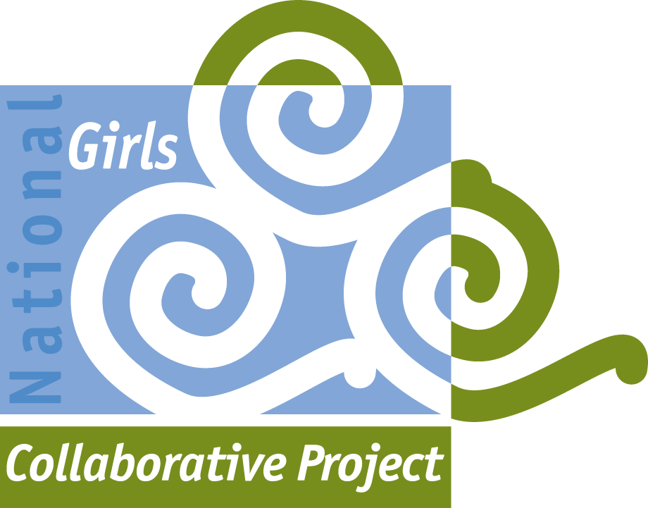
REGISTER FOR WEBINAR

This webinar is the first in a three-part series of webinars focused on STEM role models for afterschool networks and programs, presented by the National Girls Collaborative. Exposure to diverse STEM role models can broaden girls’ perceptions of STEM careers and dispel stereotypes about who does STEM. The presenters will provide an overview of STEM role models, benefits of incorporating role models into STEM programs for girls, and resources and strategies for identifying and engaging role models. In preparation for the webinar, participants are encouraged to think about how they currently use (or do not use) role models in their network or program, and identify challenges to incorporating STEM role models.

Audience: Network Leads and STEM/Moonshot Staff

PART II
March 23rd, 1:00 - 2:00 pm PST / 4:00pm - 5:00pm EST
National Girls Collaborative Project Team
Audience: Network Leads and STEM/Moonshot Staff
REGISTER FOR WEBINAR

PART III
April 27th, 1:00 - 2:00 pm PST / 4:00pm - 5:00 pm EST
National Girls Collaborative Project Team
Audience: Network Leads and STEM/Moonshot Staff
REGISTER FOR WEBINAR

ROLE MODELS MATTER WEBINARS
AUDIENCE: FOR NETWORKS LEADS AND STEM/MOONSHOT STAFF

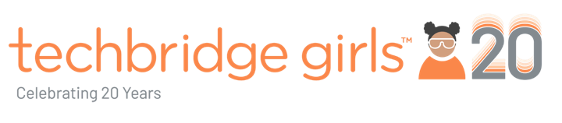

Role Models Matters Training for STEM Volunteers
April 13th, 1:00 - 2:00 pm PST / 4:00pm - 5:00 pm EST
Techbridge Girls Inc.
REGISTER FOR WEBINAR

STEM identity is critical to STEM persistence and how role models are critical to STEM identity, shared through research. In this webinar, we will explore three strategies for connecting to and preparing role models to work with youth. Strategies will consist of:

- Role Model Strategy 1: Making a Connection
- Role Model Strategy 2: Talking About Your Work in Age-Appropriate Ways
- Role Model Strategy 3: Using Culturally Relevant and Youth Development Practices

Audience: Network Leads and STEM/Moonshot Staff

QUALITY TRAININGS WITH PEAR
AUDIENCE: NETWORK LEADS OR STEM/MOONSHOT STAFF AND PROGRAM STAFF AND/OR COORDINATORS

As an implementation partner for the Million Girls Moonshot Initiative, PEAR is thrilled to offer a three-part training series to all state networks and participating programs at no cost!

We invite network leads or STEM/Moonshot staff, program staff and coordinators to leverage the free Dimensions of Success (DoS) Program Planning Tool (PPT) during these guided, interactive sessions focused on creating authentic plans to support quality programming and maximize positive outcomes for youth and educators.

PART I: Understanding Quality STEM Learning: Empowering Networks and Programs
February 23rd, 12:00 - 1:00 pm PST / 3:00pm - 4:00pm EST (Deadline to Register: February 19th)
REGISTER FOR WEBINAR

Learning Goals:
- Map the implementation of quality STEM programming practices and positive youth development by reflecting on current activities/programs
- Examine how STEM and social emotional development (SED) are interconnected and how the DoS tools/framework can support programs in elevating both

PART II: Imagining & Planning for Quality: Exploring Goals to Guide Our Work
March 11th, 12:00 - 1:00 pm PST / 3:00pm - 4:00pm EST (Deadline to Register: March 8th)
REGISTER FOR WEBINAR

Learning Goals:
- Reflect on areas of SED and STEM that are traditionally strong or challenging for programs nationally and for your program/network specifically
- Create a vision and generate goals for strengthening STEM and SED in programming using the DoS framework and tools as a guide.

PART III: Creating Change: Leveraging DoS Toward Continuous Growth
March 30th, 12:00 - 1:00 pm PST / 3:00pm - 4:00 pm EST (Deadline to Register: Friday March 26th)
REGISTER FOR WEBINAR

Learning Goals:
- Learn how to use the freely available DoS planning tool and related data collection tools to grow and strengthen programming
- Discuss how to sustainability leverage data and planning resources to continue strengthening STEM and SED in your program/network

LOOKING FOR ROLE MODELS AND MENTORS?
Our corporate partners are eager to support the Million Girls Moonshot by serving as role models, mentors, and/or general volunteers. As you know, we are currently piloting a process to coordinate Intel's employees with volunteer opportunities within the statewide afterschool networks. Please submit opportunities for Intel employees to volunteer in your state through this form Volunteer Opportunity Request Form. If there are any issues, please email Teresa Drew (tldrew@stemnext.org).

BEST PRACTICE AND PROFESSIONAL DEVELOPMENT
AUDIENCE: For Networks and Partners
APPLICATION: Share the following best practices and resources about transformative practices with partners in your state. Use them to create professional development for afterschool programs in your state.

- Podcast: STEM Role Models - In this podcast, educators, CEOs, and students discuss why STEM role models from all walks of life are essential for young peoples’ persistence and success in STEM.
- Guide: For Educators and Parents to Help Close the Gender Gap in STEM - Microsoft commissioned a survey of over 6,000 girls and young women and conducted interviews with non profit leaders. They compiled the findings in the online report — and here present a guide for teachers, parents, and education leaders. One critical strategy for success in STEM is providing role models for youth. Read more about why and how to engage role models in programs and at home.

- Toolkit: Creating Connections with Role Models: The Power of Collaboration - Designed by Techbridge Girls in collaboration with the National Girls Collaborative Project, this guide is designed to help Networks and programs understand why role models are critical to closing the gender gap in STEM. This “recipe for success” describes how programs can: incorporate role models into STEM programs, find role models, and train role models to work with youth.
- Blog: Mentor Challenge: What’s One Thing You Can Do to Make Lasting Impact? - In this blog, Dr. Linda Kekelis, Founder of Techbridge Girls, describes five ideas for mentors to help youth build social capital for thriving futures. From making social capital as important as career guidance to connecting youth with other mentoring opportunities, Dr. Kekelis provides thoughtful ways to decrease the divide between youth and resourced networks.
AUDIENCE: For Providers and Programs
APPLICATION: Share the following resources about transformative practices with program providers in your state.

- Webpage: Role Models Matter and Mentoring Works! - The National Alliance for Partnerships in Equity believes that one of the most effective ways to encourage students to consider nontraditional careers is to introduce them to diverse role models, particularly role models. This webpage serves as a resource for educators seeking STEM role models and mentors for their students.
- Videos: Role Model Profiles Video Archives SciGirls CONNECTSciGirls CONNECT - Incorporating videos from diverse STEM role models into your afterschool program is a quick way to expose students to role models. Pair your engineering activity with a video from Rachel Gitajn, a bicycle engineer, or Tejal Desai, a biomedical engineer, so students can begin making connections between afterschool, the real-world, and career.
- Posters: STEM Role Models Posters — In 7 Additional Languages - Download inspirational, diverse STEM Role Models posters for your school or afterschool program — now in 8 additional languages including Chinese, Spanish, and French.
- Stories: Stories | She Can STEM. So Can You. - Meet the women and girls of STEM. They build robots, find new sources of energy, study animals, play with slime, and invent apps. They help make the world a better (and cooler) place to be. Each story will give your students a sneak peek into how they got their start in STEM and help them begin their journey too!

TOGETHER AT HOME
AUDIENCE: For Programs, Youth and Families
APPLICATION: Share the following engineering activities with programs and families for additional STEM learning in your state.

- Student Activities: Girlstart STEM at Home was created by Girlstart to empower families and communities in STEM. Find free Girlstart curriculum, STEM resources, effective messaging tips, collaboration opportunities. Join the Girlstart newsletter and receive updated information on other online resources.
- Student Activities: EngineerGirl Try This! Design Challenge are hands-on activities using common household items. Challenges include: design a mini catapult, paper airplane, and sorting machine.

Mizzen By Mott
Mizzen By Mott inspires, engages and sparks learning in young people. Supported by the Mott Foundation, Mizzen is available at no cost to afterschool professionals! Please be sure to download the Mizzen By Mott app to access the activities below.

- Mizzen - Design a Crew Module
- Mizzen - Build An Extension Arm
- Mizzen - Build Your Own Roller Coaster

ADDITIONAL VIRTUAL PROFESSIONAL DEVELOPMENT
AUDIENCE: For Partners and Programs
APPLICATION: Share the following training opportunities with partners and program leaders to build their understanding of engineering, equity and inclusion, and STEM.
- Girl STEAM Ahead with NASA Free Resources - This 'Exemplary Practices using ‘Girls STEAM Ahead with NASA’ Free Resources' recorded webinar will explore the free NASA resources, along with accompanying exemplary practices. In addition to the content, there will be time for questions and comments in order for the NASA’s Universe of Learning team to best support your program efforts with the Girls STEAM Ahead with NASA materials.
- Gender Equity in Online Learning - When engaging girls in STEM there are many strategies and practices that support gender equity and access, but how do those strategies work in online or hybrid learning environments? This webinar will explore what works for girls from preschool and early elementary to middle school and high school, potential adaptations, and new ideas to consider when teaching girls STEM online.
ABOUT THE MGM
www.milliongirlsmoonshot.org
Please feel free to contact me with any questions. Also available to provide support are Sabrina Gomez (ms.sabrina.gomez@gmail.com) or Victoria Wegener.

