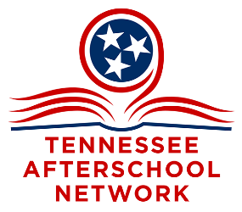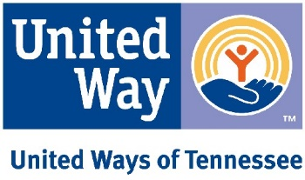
VIRTUAL HILL DAY
March 2, 2022
Talking Points

Tennessee’s New School Funding Formula:
- We’ve had a strong voice at town halls and through subcommittees and comment periods.
- The Governor and Commissioner are releasing the detailed formula/bill on February 24th.
- We anticipate being generally supportive—especially with hold harmless and cash infusion.
- UWTN and TAN are members of the TN Alliance for Equity in Education – funding reform document.
- 1-2 Central on March 1—detailed webinar on how all stacks up.
- You will receive details more “last minute”—this work will go on beyond hill day.

Handle With Care:
- Program Overview – Handle with Care (tnhandlewithcare.org)
- We are supporting HB2089 and SB2268. Rep White and Sen. Walley are the sponsors.
- There is no fiscal note—it’s just administrative to enable us to replicate this fabulous program more readily.
- As of now…On House Public Service subcommittee calendar for 2/23. Representatives Helton, Alexander, Jernigan, Johnson, Keisling, Marsh, Windle House Public Service & Employees Subcommittee - TN General Assembly
- As of now…Senate referred to State and Local Government Committee: Senators Briggs, Gardenhire, Walley, Jackson, Kelsey, Kyle, Powers, Yager, and Yarbro Senate State and Local Government Committee - TN General Assembly
- Talkers from the Tennessee Association of Chiefs of Police.

Pre-K:

We are supporting Senate Bill 2563/House Bill 1890 (Sen. Crowe, Rep. Haston)

- Looks to make Pre-K considered "elementary" for the purposes of federal funding. When ESSR funds came out, there was confusion about whether money could be spent on PreK and the confusion was not cleared up until after districts had turned in their proposals. This bill makes sure there's consensus that Pre-K is considered eligible for funding labeled "elementary.”
- As of now…on House Education Administration calendar for 2/23. Representatives White, Hurt, Baum, Carringer, Casada, Cepicky, Clemmons, Cochran, Darby, Gillespie, Hakeem, Haston, Lafferty, Love, Parkinson, and Ragan. House Education Administration Committee - TN General Assembly
- As of now…referred to Senate Education Committee. Senators Lundberg, Akbari, Bell, Crowe, Haile, Hensley, Kelsey, Powers and White. Senate Education Committee - TN General Assembly

We are also be supporting this pre-k bill: SB2179/HB2201, which would redirect sports gambling revenues to an account for the department of education to increase grants for pre-k classrooms.
- As of now…passed on to the Senate Education Committee and on calendar 3/2 Senate Education Committee - TN General Assembly. Senators Senators Lundberg, Akbari, Bell, Crowe, Haile, Hensley, Kelsey, Powers and White.
- As of now…passed on to the k-12 subcommittee and on calendar 3/1 House Education Subcommittee - TN General Assembly. Representatives Haston, Carringer, Casada, Cepicky, Clemmons, Hurt, Love, Ragan and White.
- Be aware that researchers just released the latest findings of the multi-year study following children who participated in Tennessee’s Voluntary Pre-K (VPK) program in 2009-10 and 2010-11 school years. It finds that at 6th grade (similar to what they found in 2015 at 3rd grade) the VPK children were doing worse than their control group peers in academic achievement, discipline issues and special education referrals. Talking point document from TQEE. ONLY if needed. Do not bring-up the study but be prepared if your legislator does.
- Stress--The Voluntary Pre-K initiative provides Tennessee's three- and four-year-old children—with an emphasis on four-year-olds who are at-risk—an opportunity to develop school readiness skills (pre-academic and social skills).
- Stress--Voluntary Pre-K classes promote a high-quality academic environment, which fosters the love and joy of learning and promotes success in kindergarten and throughout the child's life.
- Why Invest In a Quality Pre-K Initiative? (tn.gov)
- Share local experiences and impacts.

Value of Afterschool and Summer Programming:

This is general advocacy, and it is on our agenda for hill day for two reasons:
(1) To grease the wheels for any federal funds that may trickle our state’s way, and
(2) to ensure preservation of the recurring monies for these programs through LEAPS and 21st Century funding steams.

- This is Afterschool in Tennessee document.
- Afterschool Alliance In your state, Tennessee for the latest on unmet demand for afterschool programming.
- America After 3PM 2020 Data (afterschoolalliance.org) For the latest on unmet demand for summer programming in Tennessee.

