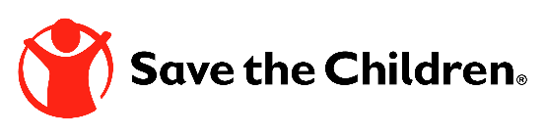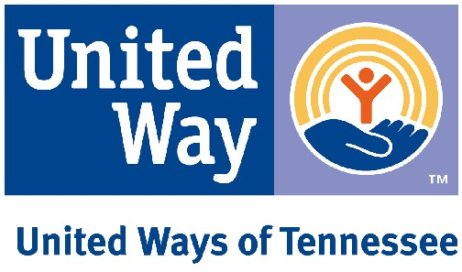

Contact: Mary Graham
615-495-9970
mary.graham@uwtn.org

NASHVILLE – TENN. – March 4, 2020

Event information: 9:00-10:30 am March 4th, Cordell Hull Building, 425 5th Ave. N., Senate Hearing Room 2, 1st Floor.

United Ways of Tennessee (UWTN), the Tennessee Afterschool Network (TAN), and Save the Children are hosting a Day on the Hill on March 4th to advocate for optimal spending of the TANF surplus (SB2797/HB2509), to promote the importance of afterschool programming, and to educate legislators on the need to reduce youth access to vaping products (SB2079/HB2114).

The event includes Advocacy Champion awards for Ralph Baldwin, publisher of the Cleveland Daily Banner, and Rick Meredith, president of the Anderson County Chamber of Commerce, as well as Legislative Champion awards for Senator Shane Reeves, Senator Katrina Robinson, Representative Robin Smith and Representative Mark White.

“It is essential that we use our TANF reserve funds effectively, targeting them for services that have the greatest impact for families living in poverty,” said Linda O’Neal, public policy chair for both UWTN and TAN. “We also need to ensure that the state’s Child Care and Development Block Grant funds are fully utilized each year to support Tennessee’s children and working parents.”

“United Ways of Tennessee recently released ALICE in Tennessee: A Financial Hardship Study. This groundbreaking report reveals that more than one in three households in Tennessee struggle to meet basic needs, and that childcare, including afterschool and summer programming, is one of the top two expenses for families with children in our state,” said Mary Graham, president of UWTN and lead staff for TAN. “The cost, availability, and scheduling of child care are often barriers to employment. In fact, nearly 53,000 parents of children 5 and younger in Tennessee have had to quit a job, not take a job, or greatly change their job because of problems with child care.” For more information about ALICE, link to: https://uwtn.org/alice.

“Afterschool programming builds social-emotional skills, including character development, self-awareness, and responsible decision-making,” noted Patrick Iannone, TN state director of programs for Save the Children and steering committee member of the TN Afterschool Network. “Quality out of school time programming also helps young people succeed in school and gain workforce skills.”

In addition to supporting programming for children, youth, and families, advocates will be talking with their legislators about the dangers of youth vaping. “SB2079/HB2114 is essential. Teen use of e-cigarettes has doubled over the last two years in Tennessee,” said Graham. “We need to protect our youth from all the harm these products do and to reduce the next generation of nicotine addicts in our state.”

“We are so pleased to present our Advocacy and Legislative Champion awards this year!” said Wendy Peay, UWTN board chair. “Awardees advocated for afterschool, for those struggling financially, for interventions around adverse childhood experiences, and for restrictions reducing youth use of vaping products. Their passion and efforts are improving the quality of life for families throughout communities in Tennessee, and we are grateful!”

Those who are unable to attend in Nashville can participate in the Digital Day on the Hill by following @TNAfterschool and @UnitedWaysTN on Facebook and Twitter March 4th. Share and like posts while using the hashtags #UWTNHillDay and #TANHillDay, and tag your state elected officials. For more information, go to the websites at www.uwtn.org and www.tnafterschool.org.

