Million Girls Moonshot - Media Assets
For August 2020
For the 50 State Afterschool Networks: The social media assets are designed to be used in conjunction with the content package here for dissemination between August 1-30, 2020. Contact Terri Ferinde for questions and if you need help customizing.

ASSETS for
- MIllion Girls Moonshot (August 2020)

Previous Media Asset Packages
- May Media Asset Package
- June Media Asset Package

Overview

The Million Girls Moonshot website is live. Feel free to share with your partners.
www.MillionGirlsMoonshot.org

Twitter: @girlsmoonshot, @STEMNext
Hashtags:
● #MillionGirlsMoonshot
● #afterschoolSTEM
● #afterschoolworks
● #thisisafterschool
● #girlsinSTEM
● #womeninSTEM
Recommended days and times to post on Facebook for education-related topics:
- Best times: Wednesday at 9 a.m. and Saturday at 5 p.m.
- Best day: Wednesday
- It is not recommended to post on Sunday

Twitter Graphics
Editable Twitter Cava Link to Graphics Can Be Found Here
Facebook Graphics
Editable Facebook Cava Link to Graphics Can Be Found Here

Social Posts for Twitter
Building culturally #competent organizations are so important! Check out this #free community tool box resource from the @UnivOfKansas where you can learn more about building a culturally competent organization. https://bit.ly/3hUU0VN #MillionGirlsMoonshot #CulturallyCompetent
In this article from @YouthToday, find out what it means to be #culturally competent in the #afterschool setting and learn specific strategies you can use & apply in everyday life! https://bit.ly/3f8RZDu #afterschoolworks #MillionGirlsMoonshot
It’s no secret that Women are under-represented in the #STEM field. Check out this scholarly article that explores how peer groups can hinder or help girls and women’s sense of belongingness in the STEM field. https://bit.ly/2XdUAG3 #womeninSTEM #girlsinSTEM
"It may seem overwhelming that, in addition to addressing overt racism in our classrooms we also need to tackle unconscious racial prejudices.” Read more in this article from @teachingtolerance, that talks about implicit bias and how to challenge it. https://bit.ly/39H2jRV #MillionGirlsMoonshot
It’s important we continue to work for change. This toolkit from @edutopia provides links and info to help you bring about change and create a more #equitable classroom. https://edut.to/3ffWagW
Check out these short videos from @TLX_ED that describe what it means to have a #culturally #responsive mindset & includes examples of specific culturally responsive practices in action! https://bit.ly/30bal2v #MillionGirlsMoonshot
Test yourself for Hidden Bias. Head over to https://bit.ly/2PcofuZs to test yourself and learn more information about #stereotypes and #prejudices & the impact they have on students. #MillionGirlsMoonshot
“Focusing on Cultural Competency in STEM Education” Check out this article that describes #culturally #responsive teaching practices, strategies for developing a culturally responsive out-of-school #STEM program and more! https://bit.ly/3faZYA5 #MillionGirlsMoonshot
This 14-episode series about #race and #racism from @DukeU is great for anyone invested in increasing #equity in #STEM. Head over to https://www.sceneonradio.org/seeing-white/ to listen! #MillionGirlsMoonshot

Social Posts for Facebook
Building culturally competent organizations are so important! Check out this free community tool box resource from the University of Kansas (@KU) where you can learn more about building a culturally competent organization. https://bit.ly/3hUU0VN
In this article from @YouthToday.org,, find out what it means to be #culturally competent in the #afterschool setting and learn specific strategies you can use & apply in everyday life! https://bit.ly/3f8RZDu
It’s no secret that Women are under-represented in the STEM field. Check out this scholarly article that explores how peer groups can hinder or help girls and women’s sense of belongingness in the STEM field. https://bit.ly/2XdUAG3
"It may seem overwhelming that, in addition to addressing overt racism in our classrooms we also need to tackle unconscious racial prejudices.” Read more in this article from @teachingtolerance.org, that talks about implicit bias and how to challenge it. https://bit.ly/39H2jRV
It’s important we continue to work for change. This toolkit from @edutopia provides links and info to help you bring about change and create a more equitable classroom. https://edut.to/3ffWagW
Check out these short videos from The Learning Exchange (@TLXON) that describe what it means to have a culturally responsive mindset & includes examples of specific culturally responsive practices in action! https://bit.ly/30bal2v
Test yourself for Hidden Bias. Head over to https://bit.ly/2PcofuZs to test yourself and learn more information about stereotypes and prejudices & the impact they have on students.
“Focusing on Cultural Competency in STEM Education” Check out this article that describes culturally responsive teaching practices, strategies for developing a culturally responsive out-of-school STEM program and more! https://bit.ly/3faZYA5
This 14-episode series about race and racism from @DukeUniv is great for anyone invested in increasing equity in STEM. Head over to https://www.sceneonradio.org/seeing-white/ to listen!

Graphics for Twitter

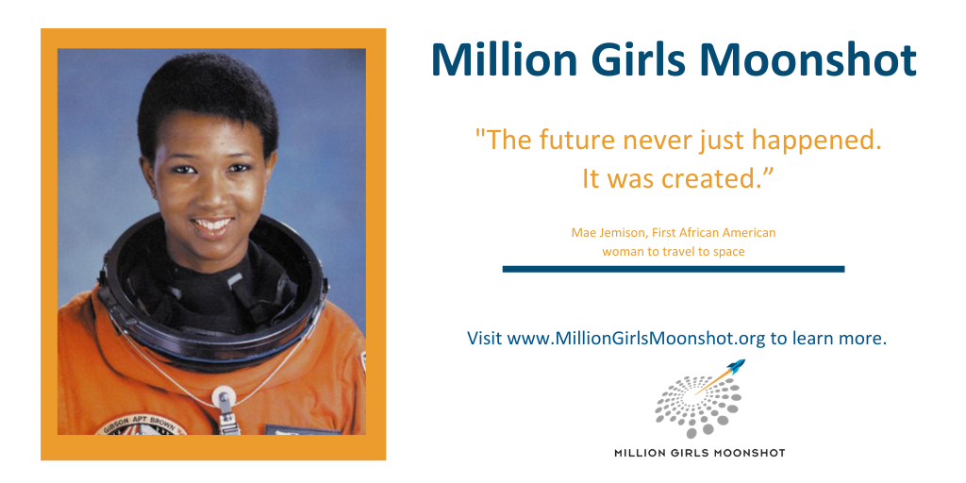
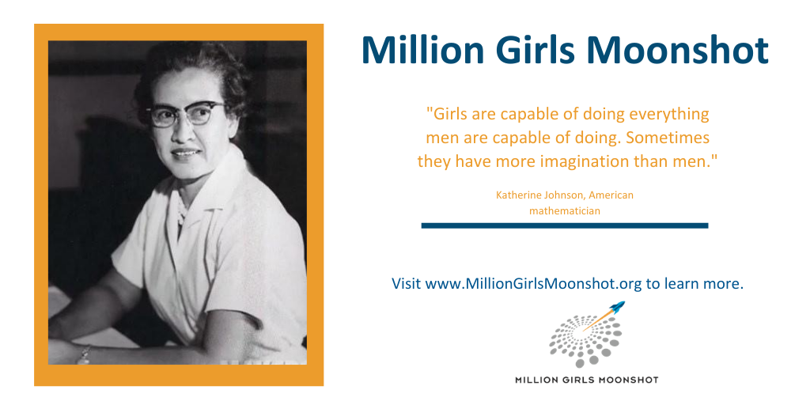

Graphics for Facebook

