Million Girls Moonshot - Media Assets
For August 2021
For the 50 State Afterschool Networks: The social media assets are designed to be used in conjunction with the content package here for dissemination between August 1-30, 2021. Contact Terri Ferinde for questions and if you need help customizing.

Content assets for August 2021

Previous Media Asset Packages

Overview

The Million Girls Moonshot website is live. Feel free to share with your partners.
www.MillionGirlsMoonshot.org

Twitter: @girlsmoonshot, @STEMNext
Hashtags:
● #MillionGirlsMoonshot
● #afterschoolSTEM
● #afterschoolworks
● #thisisafterschool
● #girlsinSTEM
● #womeninSTEM
Recommended days and times to post on Facebook for education-related topics:
- Best times: Wednesday at 9 a.m. and Saturday at 5 p.m.
- Best day: Wednesday
- It is not recommended to post on Sunday

Twitter Graphics
Editable Twitter Canva Templates Can Be Found Here
Facebook Graphics
Editable Facebook Canva Templates Can Be Found Here
*When customizing canva graphics, please remember to follow our brand guidelines that can be found here

Social Posts for Twitter

Booster Packs
- Join @LindaKekelis and @nonprofdiva for a 6 month family engagement community of practice! Don’t miss out on this opportunity to learn strategies to lead with equity - and develop your work plan → https://bit.ly/2Wfmhkp
- Learn how YOU can empower girls and young women to pursue their #STEM dreams through maker-centered learning. Check out this 4 month community of practice: https://bit.ly/3eNob1P @makers_mentors #girlsinSTEM

Booster Packs (For Programs)
- Learn how to cultivate an Engineering Mindset with activities to engage youth. You can’t miss this community of practice → https://bit.ly/3y0Xjmy @Click2Science
- Ignite. Inspire. Changemakers. You can hear from @techbridgegirls on these 3 program models this fall! https://bit.ly/2WbZjuk
- By teens, for teens. What better way to connect curious teens with #STEM experts (for free!) than through @TeenScienceCafe? Learn more: https://bit.ly/3zoA8D5

Featured Webinars
- Don’t miss the chance to see all the free design challenges offered on the @technovation Curiosity Machine website. Register today! https://bit.ly/3zoBg9N
- Calling all educators: looking for the best #AI lessons? Get the latest on artificial intelligence and how it works to solve problems: https://bit.ly/3y0o7DB @technovation
- Encourage and prepare students to solve programs with tech. Don’t miss hearing about the @technovation global program. Dive in → https://bit.ly/3zyr3I1
- Let’s hear it for the “M” in #STEM -- focus on girls and young women in mathematics with an @IfThenSheCan ambassador. Let’s make math meaningful and accessible in afterschool! https://bit.ly/3eONDnz @ngcproject #afterschoolSTEM

Featured Webinars (For Programs)
- [WEBINAR] Take a deep dive into the free Possible Futures (PF) Engineering & Design from @jfftweets curriculum on Oct. 14 at 3pm ET! Zoom link → https://bit.ly/2VcLdZ8

- Part II of @jfftweets webinar on the FREE Possible Futures (PF) Engineering & Design curriculum is Nov. 3 at 3pm ET. Don’t miss out. Zoom link: https://bit.ly/2Wr5E57

Featured Webinars (For Partners & Programs)
- Boost your #STEM learning! Hear from @IfThenSheCan to see their new afterschool portal and find new activities designed just for #afterschool: https://bit.ly/3rvyFrJ @ngcproject
- WATCH: Gear up for Camp @goldieblox! Join @ngcproject to explore new episodes & find resources to inspire the next generation of girls in #STEM → https://bit.ly/2UUGueS
- Role models matter. Access this helpful volunteer and role model training from @techbridgegirls: https://bit.ly/3zHLfaz #girlsinSTEM #womeninSTEM

Transformative Practices
- From the CAISE #STEM Taskforce: A toolkit w/ resources to make your ISE & science communication work more inclusive: https://bit.ly/3eP20Zd @informalscience
- Looking to lead discussions on broadening participation in your #STEM organization or program? Check out this helpful conversation guide from @informalscience → https://bit.ly/3iWCxyr
- From @informalscience: practice brief to help you reflect on the cultural norms of #STEM https://bit.ly/2V80bPW
- Add this to your reading list → “What STEM Mindset Is … and Why Everyone Should Have One” from @NSTA https://bit.ly/3eOJobO
National Aviation Day (August 19)
- This #NationalAviationDay learn more about @IfThenSheCan ambassador Adele Luta Long! https://bit.ly/3x1GrLk @serenity_astra
- Learn more about a day in the life of scientist & @IfThenSheCan ambassador Adele Luta Long! Watch here: https://bit.ly/2V4phPO @serenity_astra #NationalAviationDay
- Jasmine Sadler didn’t become the dancing rocket scientist overnight! This #NationalAviationDay find out her #STEM journey → https://bit.ly/3kPtTEu @IfThenSheCan @thejasmaven
- Happy #NationalAviationDay! Hear dancing rocket scientist Jasmine Sadler discuss a day on the job: https://bit.ly/3zr97io @IfThenSheCan @thejasmaven
- Learn more about how planes stay in the air for this #NationalAviationDay. Watch now ✈️ https://bit.ly/2TxlhqL
- Your quick Q answered: Hear more about the importance of satellites directly from an aerospace engineer! https://bit.ly/3xWVLKm #NationalAviationDay

- Get crafty this #NationalAviationDay: build your own satellite! https://bit.ly/3zso8QX @goldieblox

Families
- Social support from parents can sustain youth participation in computing. Read more from @ricarose https://bit.ly/3eRzBBT

- Watch this recording of the Listen, Learn, Lead webinar from @FlamboyanFDN to spark ideas to engage important stakeholders today & beyond → https://bit.ly/36UxcSz

STEM Transitions, Handoffs, and Coordination
- Toolkit: Brokering Youth Pathways gives techniques to connect youth to future #STEM learning opportunities & resources. Check it out here → https://bit.ly/3eOGK5T

- Don’t miss this report from @TheCLAlliance sharing empirical research on new media/learning, design, case studies and more: https://bit.ly/3i1L3wC

Activities for Programs
- From @TeachNgineering: encourage your student to become a product engineer in a bouncy ball factory → https://bit.ly/3kWCFAh
- Student challenge: engineer a table using newspaper! Learn more here: https://bit.ly/2UHFMBK @DesignSquad
- Fly to the highest heights with your growing engineer -- try this Take Flight activity & explore how flight is possible: https://bit.ly/3zBwEgx @TryEngineering
- Keep it cool this summer with your student #engineer. Design build, and test a cooler with @TeachNgineering → https://bit.ly/3kYBBfd
- With @DesignSquad Watercraft challenge, young engineers can design and build a boat out of only straws and plastic wrap. Check it out! https://bit.ly/3zEe3ke
- Get it “Write” with @TryEngineering -- students create their own functional pen with everyday materials 🖊 https://bit.ly/3BGIGan

Additional Professional Development
- Curious about Curiosity Camp? Join @IfThenSheCan Collection & CEO of @GoldieBlox @debbieblox to learn how you can use Curiosity Camp resources to support #STEM role models for girls https://bit.ly/2WbawLx
- Don’t miss the chance to hear from @IfThenSheCan about their available resources & activities for #girlsinSTEM: https://bit.ly/3i785SE
- How can we address stereotypes in #STEM - for girls and especially girls of color? Join @ngcproject to hear more about how to engage in these challenging conversations & help girls see their future selves in #STEM → https://bit.ly/3iS1ZES #girlsinSTEM

Social Posts for Facebook

Booster Packs
- Don’t miss out on this opportunity to learn strategies to lead with equity and develop your work plan for a 6 month family engagement community of practice → https://bit.ly/2Wfmhkp
- YOU can empower girls and young women to pursue their STEM dreams through maker-centered learning. Check out this 4 month community of practice with @MakersMentors: https://bit.ly/3eNob1P

Booster Packs (For Programs)
- Learn how to cultivate an Engineering Mindset with activities to engage youth. You can’t miss this community of practice → https://bit.ly/3y0Xjmy @Click2Science
- Ignite. Inspire. Changemakers. You can hear from @techbridgegirls on these 3 program models this fall! https://bit.ly/2WbZjuk
- By teens, for teens. What better way to connect curious teens with STEM experts (for free!) than through Teen Science Cafe? Learn more: https://bit.ly/3zoA8D5

Featured Webinars
- Don’t miss the chance to see all the free design challenges offered on the @technovationglobal Curiosity Machine website. Register today! https://bit.ly/3zoBg9N
- Calling all educators: looking for the best #AI lessons? Get the latest on artificial intelligence and how it works to solve problems: https://bit.ly/3y0o7DB @technovationglobal
- Encourage and prepare students to solve programs with tech. Don’t miss hearing about @technovationglobal programs. Dive in → https://bit.ly/3zyr3I1
- Let’s hear it for the “M” in #STEM -- focus on girls and young women in mathematics with an @IfThenInitiative ambassador. Let’s make math meaningful and accessible in afterschool! https://bit.ly/3eONDnz @ngcproject #afterschoolSTEM

Featured Webinars (For Programs)
- [WEBINAR] Take a deep dive into the free Possible Futures (PF) Engineering & Design from @jobsforthefuture curriculum on Oct. 14 at 3pm ET! Zoom link → https://bit.ly/3kNQ0Lj
- Part II of @jobsforthefuture webinar on the FREE Possible Futures (PF) Engineering & Design curriculum is Nov. 3 at 3pm ET. Don’t miss out. Zoom link: https://bit.ly/3Bz2VGZ

Featured Webinars (For Partners & Programs)
- Boost your #STEM learning! Hear from @IfThenInitiative to see their new afterschool portal and find new activities designed just for #afterschool: https://bit.ly/3rvyFrJ @ngcproject
- WATCH: Gear up for Camp @GoldieBlox! Join @ngcproject to explore new episodes & find new resources to inspire the next generation of girls in #STEM → https://bit.ly/3eK4vMr
- Role models matter. Access this helpful volunteer and role model training from @techbridgegirls: https://bit.ly/3zHLfaz

Transformative Practices
- From the CAISE #STEM Taskforce: A toolkit w/ resources to make your ISE & science communication work more inclusive: https://bit.ly/3eP20Zd @informalscience
- Looking to lead discussions on broadening participation in your #STEM organization or program? Check out this helpful conversation guide from @informalscience → https://bit.ly/3iWCxyr
- From @informalscience: practice brief to help you reflect on the cultural norms of #STEM https://bit.ly/2V80bPW
- Add this to your reading list → “What STEM Mindset Is … and Why Everyone Should Have One” from @NSTA.FB https://bit.ly/3eOJobO
National Aviation Day (August 19)
- This #NationalAviationDay learn more about @IfThenInitiative ambassador Adele Luta Long! https://bit.ly/3x1GrLk
- Learn more about a day in the life of scientist & @IfThenInitiative ambassador Adele Luta Long! Watch here: https://bit.ly/2V4phPO #NationalAviationDay
- @jasminesadler didn’t become the dancing rocket scientist overnight! This #NationalAviationDay find out her #STEM journey → https://bit.ly/3kPtTEu @IfThenInitiative
- Happy #NationalAviationDay! Hear dancing rocket scientist Jasmine Sadler discuss a day on the job: https://bit.ly/3zr97io @IfThenInitiative @jasminesadler
- Learn more about how planes stay in the air for this #NationalAviationDay. Watch now ✈️ https://bit.ly/2TxlhqL
- Your quick Q answered: Hear more about the importance of satellites directly from an aerospace engineer! https://bit.ly/3xWVLKm #NationalAviationDay

- Get crafty this #NationalAviationDay: build your own satellite! https://bit.ly/3zso8QX @GoldieBlox

Families
- Social support from parents can sustain youth participation in computing. Read more: https://bit.ly/3eRzBBT

- Watch this recording of the Listen, Learn, Lead webinar from @flamboyanfoundation to spark ideas to engage important stakeholders today & beyond → https://bit.ly/36UxcSz

STEM Transitions, Handoffs, and Coordination
- Toolkit: Brokering Youth Pathways gives techniques to connect youth to future #STEM learning opportunities & resources. Check it out here → https://bit.ly/3eOGK5T

- Don’t miss this report from @ConnectedLearningAlliance sharing empirical research on new media/learning, design, case studies and more: https://bit.ly/3i1L3wC

Activities for Programs
- From @TeachEngineeringDigitalLibrary: encourage your student to become a product engineer in a bouncy ball factory → https://bit.ly/3kWCFAh
- Student challenge: engineer a table using newspaper! Learn more here: https://bit.ly/2UHFMBK @DesignSquadPBS
- Fly to the highest heights with your growing engineer -- try this Take Flight activity & explore how flight is possible: https://bit.ly/3zBwEgx @TryEngineering.org
- Keep it cool this summer with your student #engineer. Design build, and test a cooler with @TeachEngineeringDigitalLibrary → https://bit.ly/3kYBBfd
- With @DesignSquadPBS Watercraft challenge, young engineers can design and build a boat out of only straws and plastic wrap. Check it out! https://bit.ly/3zEe3ke
- Get it “Write” with @TryEngineering.org -- students create their own functional pen with everyday materials 🖊 https://bit.ly/3BGIGan

Additional Professional Development
- Curious about Curiosity Camp? Join @IfThenInitiative Collection & CEO of @GoldieBlox to learn how you can use Curiosity Camp resources to support #STEM role models for girls https://bit.ly/2WbawLx
- Don’t miss the chance to hear from @IfThenInitiative about their available resources & activities for #girlsinSTEM: https://bit.ly/3i785SE
- How can we address stereotypes in #STEM - for girls and especially girls of color? Join @ngcproject to hear more about how to engage in these challenging conversations & help girls see their future selves in #STEM → https://bit.ly/3iS1ZES #girlsinSTEM

Graphics for Twitter
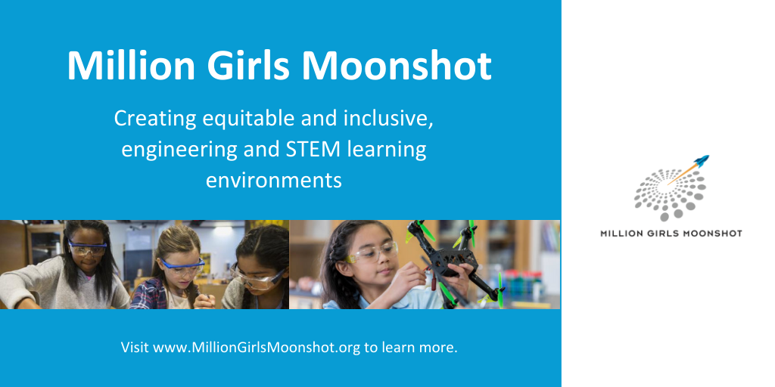

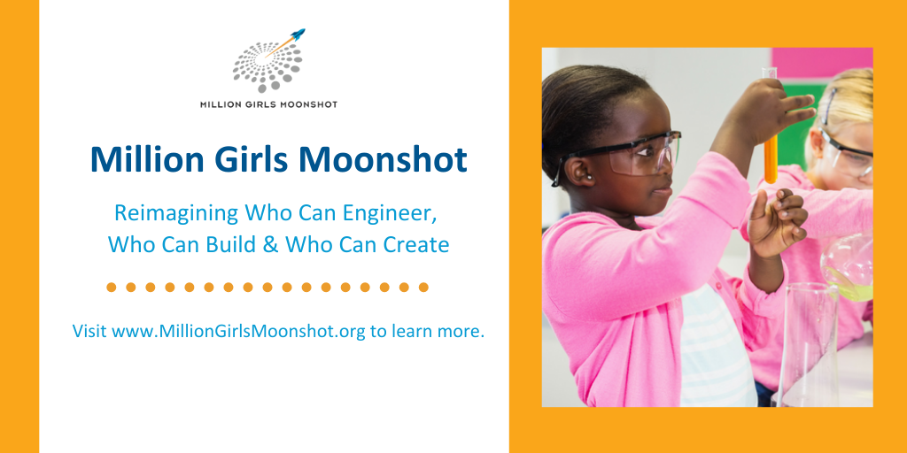

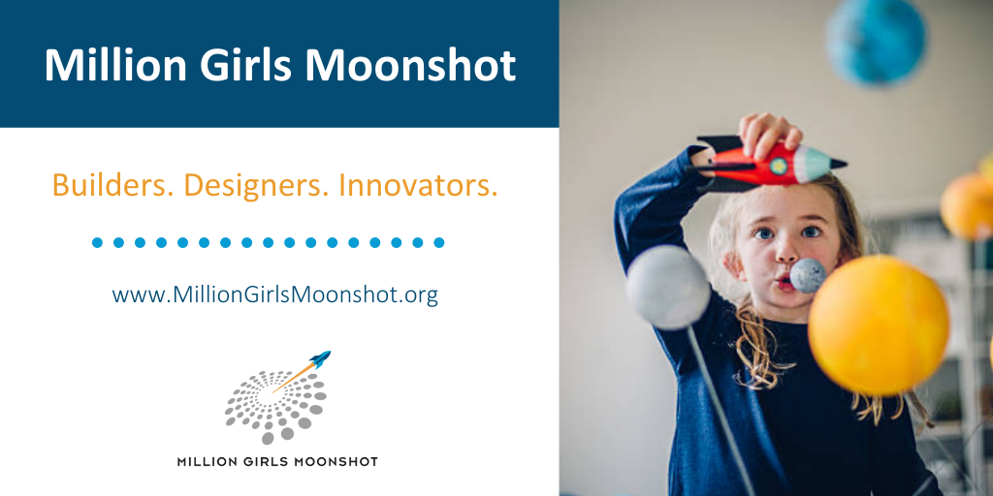

Graphics for Facebook
