Million Girls Moonshot - Media Assets
For December 2020
For the 50 State Afterschool Networks: The social media assets are designed to be used in conjunction with the content package here for dissemination between December 1-31, 2020. Contact Terri Ferinde for questions and if you need help customizing.

ASSETS for November 2020
- MIllion Girls Moonshot
- Engineering Mindset

Previous Media Asset Packages
- May Media Asset Package
- June Media Asset Package
- August Media Asset Package
- September Asset Package
- October Asset Package
- November Asset Package

Overview

The Million Girls Moonshot website is live. Feel free to share with your partners.
www.MillionGirlsMoonshot.org

Twitter: @girlsmoonshot, @STEMNext
Hashtags:
● #MillionGirlsMoonshot
● #afterschoolSTEM
● #afterschoolworks
● #thisisafterschool
● #girlsinSTEM
● #womeninSTEM
Recommended days and times to post on Facebook for education-related topics:
- Best times: Wednesday at 9 a.m. and Saturday at 5 p.m.
- Best day: Wednesday
- It is not recommended to post on Sunday

Twitter Graphics
Editable Twitter Cava Templates Can Be Found Here
Facebook Graphics
Editable Facebook Cava Templates Can Be Found Here
*When customizing canva graphics, please remember to follow our brand guidelines that can be found here

Social Posts for Twitter

Check out this rubric that allows you to assess the maturity of a partnership & provides some direction for growth! https://bit.ly/3mBmJSi
Looking for a good read this December? Check out this book on youth development in out-of-school time settings! It includes a chapter on 10 principles of effective youth development. Read more: https://bit.ly/2JBbtqf
Last year, @ncldorg launched an initiative - Why Us? Why Now? Be sure to head over to their website to download this PDF that identifies key strategies, case studies & actions for impact. https://bit.ly/3mwIFhn
Check it out! @techbridgegirls Essential elements are guiding principles for high-quality, #equitable #STEM programs for #girls. These essential elements are based on Techbridge Girls’ 18 years of experience in the STEM field.​ https://bit.ly/3mH7EOn
Check it out! This guide from @techbridgegirls is designed to help you recruit and prepare role models to inspire girls in #STEM. https://bit.ly/2I2P4Sp
As #FutureEngineers it’s important to look at the different kinds of materials and identify their properties. In this activity by @aaas, kids can examine the #properties, #limitations & #durability of different materials. https://bit.ly/3jsA8td #MillionGirlsMoonshot

#Engineering is all around us & is one of the many reasons we love this activity from @NatGeoEducation, where kids brainstorm solutions to location and water-based issues and discuss how these were addressed in #real projects. https://bit.ly/35XLkcP #MillionGirlsMoonshot
How high can a super ball bounce? In this #engineering activity, youth explore how engineers might use elasticity of #material to help them design products. https://bit.ly/3mBocYw @TeachNgineering
From school gardening, to classroom renovation. Check out this website from @TuftsCEEO that provides engineering challenges that are community-based & introduces kids to #engineering as a strategy for tackling real world problems. https://communityengineering.org/resources/
Develop #curiosity, creativity and confidence through family-friendly, hands-on activities! Sign up for hundreds of #FREE Technovation Engineering Design Activities with facilitation instructions & videos featuring STEM professionals and mentors. More info: https://www.curiositymachine.org/ @technovation

Social Posts for Facebook
Check out this rubric that allows you to assess the maturity of a #partnership & provides some direction for growth! https://bit.ly/3mBmJSi
Looking for a good read this December? Check out this book on youth development in out-of-school time settings! It includes a chapter on 10 principles of effective youth development. Read more: https://bit.ly/2JBbtqf
Last year, @ncld.org launched an initiative - Why Us? Why Now? Be sure to head over to their website to download this PDF that identifies key strategies, case studies & actions for impact. https://bit.ly/3mwIFhn
Check it out! @techbridgegirls Essential elements are guiding principles for high-quality, equitable STEM programs for girls. These essential elements are based on Techbridge Girls’ 18 years of experience in the STEM field.​ https://bit.ly/3mH7EOn
Check it out! This guide from @techbridgegirls is designed to help you recruit and prepare role models to inspire girls in #STEM. https://bit.ly/2I2P4Sp
As future engineers it’s important to look at the different kinds of materials and identify their properties. In this activity by @aaas.science kids can examine the properties, limitations & durability of different materials. https://bit.ly/3jsA8td
Engineering is all around us & is one of the many reasons we love this activity from @InsideNatGeo, where kids brainstorm solutions to location and water-based issues and discuss how these were addressed in #real projects. https://bit.ly/35XLkcP
How high can a super ball bounce? In this engineering activity, youth explore how engineers might use elasticity of material to help them design products. https://bit.ly/3mBocYw @TeachEngineeringDigitalLibrary
From school gardening, to classroom renovation. Check out this website from @TuftsCEEO that provides engineering challenges that are community-based & introduces kids to #engineering as a strategy for tackling real world problems. https://communityengineering.org/resources/
Develop curiosity, creativity and confidence through family-friendly, hands-on activities! Sign up for hundreds of FREE Technovation Engineering Design Activities with facilitation instructions & videos featuring STEM professionals and mentors. More info: https://www.curiositymachine.org/ @technovationglobal

Graphics for Twitter
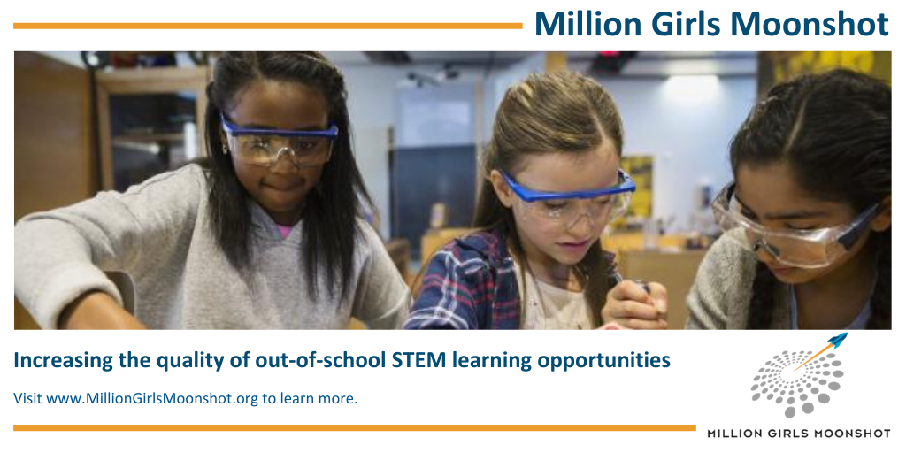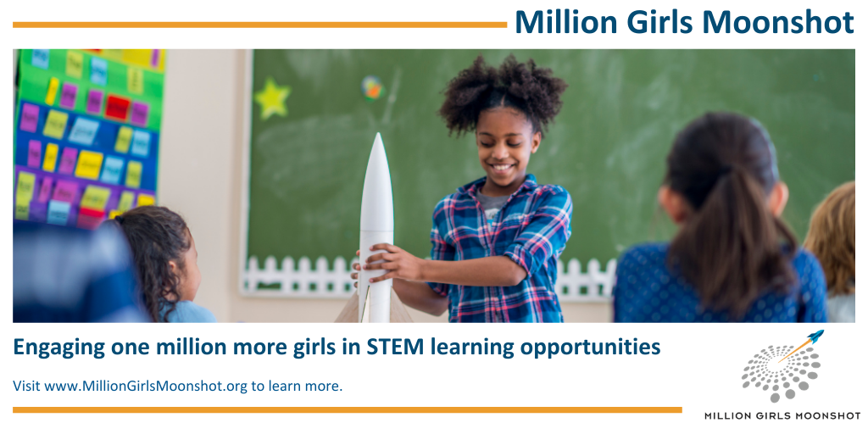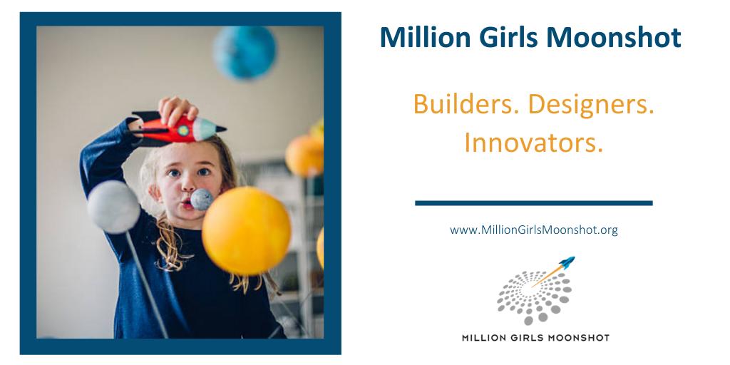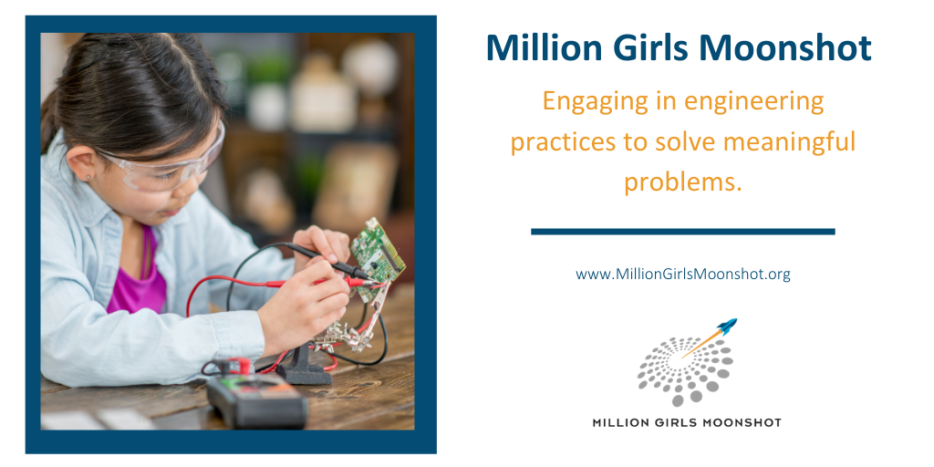

Graphics for Facebook

