Million Girls Moonshot - Media Assets
For February 2021
For the 50 State Afterschool Networks: The social media assets are designed to be used in conjunction with the content package here for dissemination between February 1-28, 2021. Contact Terri Ferinde for questions and if you need help customizing.

ASSETS for February 2021
- Million Girls Moonshot
- Engineering Mindset

Previous Media Asset Packages
- May Media Asset Package
- June Media Asset Package
- August Media Asset Package
- September Asset Package
- October Asset Package
- November Asset Package
- December Asset Package

Overview

The Million Girls Moonshot website is live. Feel free to share with your partners.
www.MillionGirlsMoonshot.org

Twitter: @girlsmoonshot, @STEMNext
Hashtags:
● #MillionGirlsMoonshot
● #afterschoolSTEM
● #afterschoolworks
● #thisisafterschool
● #girlsinSTEM
● #womeninSTEM
Recommended days and times to post on Facebook for education-related topics:
- Best times: Wednesday at 9 a.m. and Saturday at 5 p.m.
- Best day: Wednesday
- It is not recommended to post on Sunday

Twitter Graphics
Editable Twitter Cava Templates Can Be Found Here
Facebook Graphics
Editable Facebook Cava Templates Can Be Found Here
*When customizing canva graphics, please remember to follow our brand guidelines that can be found here

Social Posts for Twitter
- #STEM learning can continue at home with these resources from @Girlstart! Check out these engaging activities, engineering challenges & other STEM experiences that you can do at home! #STEMatHome #afterschoolSTEM https://bit.ly/3j8JJqL
- #Engineering is all around us! Check out Engineer Girls “Try This! Design Challenge” where you can do some hands-on activities using common household items. @EngineerGirlNAE #STEMatHome #afterschoolSTEM https://www.engineergirl.org/128249/Try-This

Social Posts for Facebook
- STEM learning can continue at home with these resources from Girlstart! Check out these engaging activities, engineering challenges & other STEM experiences that you can do at home with the whole family! https://bit.ly/3j8JJqL
- Engineering is all around us! Check out Engineer Girls “Try This! Design Challenge” where you can do some hands-on activities using common household items. https://www.engineergirl.org/128249/Try-This

Graphics for Twitter
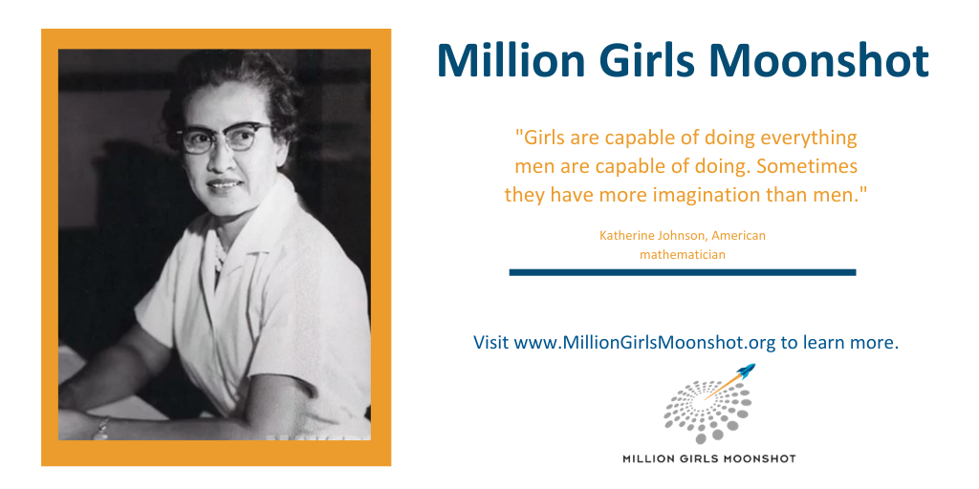

Graphics for Facebook

