Million Girls Moonshot - Media Assets
For May 2020
For the 50 State Afterschool Networks: The social media assets are designed to be used in conjunction with the content package here for dissemination between May 1-31, 2020. Contact Terri Ferinde for questions and if you need help customizing.

ASSETS for
- MIllion Girls Moonshot
- Engineering Mindset

Overview

The Million Girls Moonshot website is live. Feel free to share with your partners.
www.MillionGirlsMoonshot.org

All graphics can be found here
- https://www.dropbox.com/sh/r2ljj1gpmu2iaqf/AACm3kf3c4dlpZAAvOB1UFsba?dl=0

Twitter: @girlsmoonshot, @STEMNext
Hashtags:
● #MillionGirlsMoonshot
● #afterschoolSTEM
● #afterschoolworks
● #thisisafterschool
● #girlsinSTEM
● #womeninSTEM
Recommended days and times to post on Facebook for education-related topics:
- Best times: Wednesday at 9 a.m. and Saturday at 5 p.m.
- Best day: Wednesday
- It is not recommended to post on Sunday

Social Posts for Featured Resources

Twitter
Attention #Teachers: This short survey is a simple way for students to reflect on their Engineering Mindset development. More info: https://bit.ly/2L7KqQY @RAEngNews #STEM #EngineerLearning #MillionGirlsMoonshot #girlsinSTEM

“Engineering is all around us, so it’s often taken for granted.” Check out this @TeachEngineering video that showcases real engineers and the work they do. https://bit.ly/3ahSpEZ #STEM #EngineerLearning @STEMNext #MillionGirlsMoonshot #afterschoolworks

#Engineers use knowledge and #creativity to find solutions to society’s problems. Head over to @LinkEngOrg website to learn more about the habits of engineers. https://bit.ly/3b9mzuE via @CSLJournal. #EngineerLearning #MillionGirlsMoonshot #girlsinSTEM #womeninSTEM @girlsmoonshot

“Someone with a #STEM mindset sees the potential of science, technology, engineering, and mathematics to be valuable and relevant to their lives and communities and in the world.” Read more about STEM Mindset here: https://bit.ly/2W7TYlh #womeninSTEM #girlsinSTEM #MillionGirlsMoonshot @girlsmoonshot

#Teachers play an important role in developing students #EngineeringMindset. The questions students ask and how teachers respond can have powerful effects. https://bit.ly/2yyo9cj via @DefinedLearning #MillionGirlsMoonshot

#ThinkLikeAnEngineer. Check it out! This activity book provides an introduction to the skills and process used by engineers. It’s also coded to indicate which of the four features of engineering they focus on. https://bit.ly/2zjIaUc #STEMLearning @STEMNext @girlsmoonshot
An #EngineeringMindset refers to the values, attitudes, and thinking skills associated with #engineering. We created this one-page document that provides the definition of engineering mindset and describes the critical engineering practices that support it. https://bit.ly/2zjIaUc #STEMLearning @STEMNext @girlsmoonshot

Facebook

Attention Teachers! Here is a free STEM resource. This short survey is a simple way for your students to reflect on their Engineering Mindset development. For more info, visit: https://bit.ly/2L7KqQY

“Engineering is all around us, so it’s often taken for granted.” This video showcases real engineers and the work they do. Visit https://bit.ly/3ahSpEZ watch the full video and learn more about engineers at work!

The Million Girls Moonshot will help us reimagine who can engineer, who can build and who can make. We created this printable graphic for you that presents the10 critical engineering practices and shows how they all contribute to the development of an engineering mindset. Download here: https://bit.ly/2yGxaQs and visit our website for more information: https://milliongirlsmoonshot.org

Engineers use knowledge and creativity to find solutions to society’s problems. Visit to https://bit.ly/3b9mzuE to learn more about the habits of engineers and how all future engineers can develop their Engineering Mindset.

“Someone with a STEM mindset sees the potential of science, technology, engineering, and mathematics to be valuable and relevant to their lives and communities and in the world.” Read more about having a STEM Mindset here: https://bit.ly/2W7TYlh

Teachers play an important role in developing their students' Engineering Mindsets. The questions students ask and how teachers respond can have powerful effects. Read more in this article by (@DefinedLearning) https://bit.ly/2yyo9cj on the important role teachers play.

Let’s think like engineers! This activity book provides an introduction to the skills and process used by engineers. It’s also coded to indicate which of the four features of engineering they focus on. https://bit.ly/2zjIaUc
Having an engineering mindset refers to the values, attitudes, and thinking skills associated with engineering. To make things easier for all our future engineers, we created this one-page document that provides the definition of engineering mindset and describes the critical engineering practices that support it. https://bit.ly/2zjIaUc

ENGINEERING MINDSET SOCIAL POSTS

Twitter:
The #MillionGirlsMoonshot will help us reimagine who can #engineer, who can build and who can make. Check out this printable graphic that we created that presents the10 critical engineering practices and shows how they all contribute to the development of an engineering mindset. https://bit.ly/2yGxaQs @STEMNext #girlsinSTEM #afterschoolworks #afterschoolSTEM

Here is a #tip for developing an #EngineeringMindset.
Explore Materials. #Engineers consider the properties of materials and select those that are most appropriate for the task. https://bit.ly/2yGxaQs @STEMNext #girlsinSTEM #afterschoolworks #afterschoolSTEM

Developing an #EngineeringMindset means using #Science & #Math to solve problems! Click the link to access a printable graphic that explores more practices for developing help an Engineering Mindset. https://bit.ly/2yGxaQs @STEMNext #girlsinSTEM #WomeninSTEM #afterschoolworks #afterschoolSTEM #MillionGirlsMoonshot

Did you know #Engineers solve problems using a systematic process called the Engineering Design Process? Head over to our website to learn more about how engineers develop their #EngineeringMindset.https://milliongirlsmoonshot.org and click the link here to access our printable graphic https://bit.ly/2zjIaUc @STEMNext #girlsinSTEM #afterschoolSTEM #MillionGirlsMoonshot

Calling all #FutureEngineers! Here is some quick advice. The first step in becoming an #engineer is identifying as one. For more quick advice, click here https://bit.ly/2zjIaUc and headover to our website for more information https://milliongirlsmoonshot.org @STEMNext @girlsmoonshot #girlsinSTEM #WomeninSTEM #afterschoolworks #afterschoolSTEM #MillionGirlsMoonshot

Developing an #EngineeringMindset means balancing criteria. To learn more: https://bit.ly/2zjIaUc and headover to our website for more information https://milliongirlsmoonshot.org @STEMNext #girlsinSTEM #WomeninSTEM #afterschoolworks #afterschoolSTEM #MillionGirlsMoonshot

#InnovativeThinking goes a long way! #Engineers often have to think innovatively and make informed recommendations about open-ended #problems. To learn more click here: https://bit.ly/2zjIaUc and and headover to our website for more information https://milliongirlsmoonshot.org @STEMNext #girlsinSTEM #WomeninSTEM #MillionGirlsMoonshot

#Persistence is key! #Engineers learn from failure so they can #revise and #improve their designs. To learn more: https://bit.ly/2zjIaUc and headover to our website for more information https://milliongirlsmoonshot.org @STEMNext #afterschoolworks #afterschoolSTEM #MillionGirlsMoonshot

Evaluation is key! #Engineers often collect and analyze their data to make needed improvements. To learn more: https://bit.ly/2zjIaUc and and headover to our website for more information https://milliongirlsmoonshot.org @STEMNext #girlsinSTEM #WomeninSTEM #afterschoolworks #afterschoolSTEM #MillionGirlsMoonshot

When it comes to developing an #EngineeringMindset we’ve got you covered! Check out this tip on working effectively in #teams. To learn more, click here: https://bit.ly/2zjIaUc and headover to our website for more information https://milliongirlsmoonshot.org @STEMNext #girlsinSTEM #afterschoolSTEM #MillionGirlsMoonshot

Did you know that #Engineers often design solutions for specific REAL world problems? To learn more, click here: https://bit.ly/2zjIaUc and headover to our website for more information https://milliongirlsmoonshot.org @STEMNext #girlsinSTEM #afterschoolworks #afterschoolSTEM #MillionGirlsMoonshot

Facebook

Given the challenges we are facing as a society, this month our focus is building an Engineering Mindset. We’ve created this printable graphic that presents the10 critical engineering practices and shows how they all contribute to the development of an engineering mindset. Download here: https://bit.ly/2yGxaQs and visit our website for more information: https://milliongirlsmoonshot.org

Here is a tip for developing an Engineering Mindset.
Explore Materials. Engineers consider the properties of materials and select those that are most appropriate for the task. To learn more: https://bit.ly/2zjIaUc and visit our website for more information: https://milliongirlsmoonshot.org

Here is some advice for the future engineers out there. The first step in becoming an engineer is identifying as one. For more quick advice, https://bit.ly/2zjIaUc and visit our website for more information: https://milliongirlsmoonshot.org

When it comes to developing an Engineering Mindset we’ve got you covered! Check out this tip on working effectively in teams. To learn more, click here: https://bit.ly/2zjIaUc and visit our website for more information: https://milliongirlsmoonshot.org

Additional Post (Feel free to use if needed)
Twitter:
Launching #MillionGirlsMoonshot with @stemnext to inspire more #GirlsinSTEM. #Afterschoolworks and together we will inspire future innovators – girls and boys!

Inspiring and preparing the next generation of innovators by engaging 1 million girls in #STEM learning thru afterschool programs. The #MillionGirls Moonshot will inspire #girlsinSTEM #thisisafterschoolwww.milliongirlsmoonshot.org
#Afterschool fosters collaboration, creativity and communication. #MillionGirlsMoonshot #GirlsinSTEM. For more: www.milliongirlsmoonshot.org
#AfterschoolSTEM gives girls the opportunity to tinker, learn and explore #STEM topics. That’s why we’re part of the #MillionGirlsMoonshot. More: www.milliongirlsmoonshot.org
The #MillionGirlsMoonshot will help us re-imagine who can engineer, who can build and who can make. Join us as we help girls reach their potential for greatness. www.milliongirlsmoonshot.org #WomeninSTEM #afterschoolworks #afterschoolSTEM

The more kids participate in #afterschool, the more interested they become in #STEM subjects.www.milliongirlsmoonshot.org #MillionGirlsMoonshot #GirlsinSTEM
Check it out! These five #DIY family-friendly projects using ordinary household items to spark #creativity while keeping kids engaged and #learning. https://bit.ly/3ba4T2S #MillionGirlsMoonshot #GirlsinSTEM

#STEMAtHome was created by @girlstart to empower families and communities in #STEM. Check out the website which features STEM resources, tips and more! https://bit.ly/2RCvEW3 #MillionGirlsMoonshot #GirlsinSTEM

Facebook:
The Million Girls Moonshot will re-imagine who can engineer, who can build and who can create. Get inspired, join the movement at www.MillionGirlsMoonshot.org

Women are half of the U.S. college-educated workforce, but only 29 percent of the science and engineering workforce and less than 3% are women of color. The Million Girls Moonshot aims to change that by engaging girls and boys with consistent, high-quality STEM afterschool programming. www.MillionGirlsMoonshot.org

Twitter Graphics
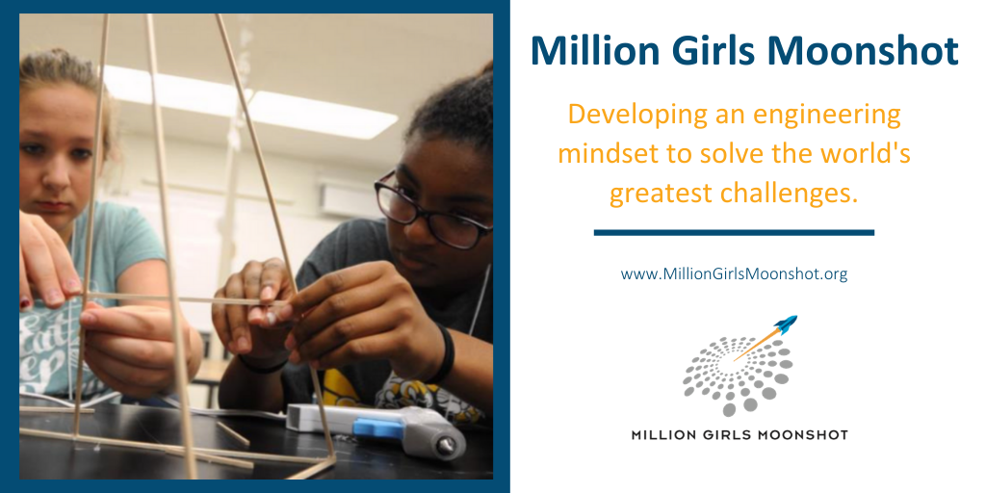
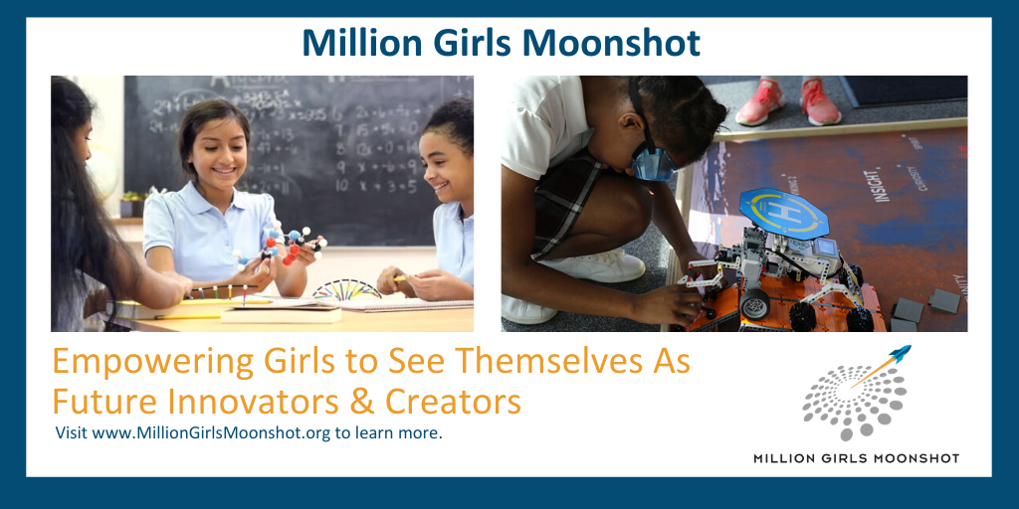

Facebook Graphics

