Million Girls Moonshot - Media Assets
For November 2020
For the 50 State Afterschool Networks: The social media assets are designed to be used in conjunction with the content package here for dissemination between November 1-30, 2020. Contact Terri Ferinde for questions and if you need help customizing.

ASSETS for November 2020
- MIllion Girls Moonshot
- Engineering Mindset

Previous Media Asset Packages
- May Media Asset Package
- June Media Asset Package
- August Media Asset Package
- September Asset Package
- October Asset Package

Overview

The Million Girls Moonshot website is live. Feel free to share with your partners.
www.MillionGirlsMoonshot.org

Twitter: @girlsmoonshot, @STEMNext
Hashtags:
● #MillionGirlsMoonshot
● #afterschoolSTEM
● #afterschoolworks
● #thisisafterschool
● #girlsinSTEM
● #womeninSTEM
Recommended days and times to post on Facebook for education-related topics:
- Best times: Wednesday at 9 a.m. and Saturday at 5 p.m.
- Best day: Wednesday
- It is not recommended to post on Sunday

Twitter Graphics
Editable Twitter Cava Link to Graphics Can Be Found Here
Facebook Graphics
Editable Facebook Cava Link to Graphics Can Be Found Here
*When customizing canva graphics, please remember to follow our brand guidelines that can be found here

Social Posts for Twitter

This brief from @STEMTeachTools talks about the importance of supporting #students as they collect & use #data to help them decide what improvements to make as they redesign and iterate throughout the engineering design process! https://rb.gy/9plnvx
Engineering design failures can sometimes lead to #student frustration. This brief from @STEMTeachTools gives #teachers advice on how to manage & redirect students' frustration, so that they can "fail forward" and learn from their mistakes! https://bit.ly/37XFRFE
Check it out! This @EdWeekTeacher article gives #teachers advice on how to increase the quality and effectiveness of collaborative group work. Read more here: https://bit.ly/37X7xug
Developing a #STEM identity in youth is so important! This self-directed online course from @Click2Science provides examples & practical #tips about developing STEM identity in youth. https://bit.ly/3jJXcUs.
Did you know that developing a science-related identity increases engagement & also increases the likelihood that #students pursue a career in a science or STEM-related field? Head over to https://bit.ly/31SYpmv to read more!
We love #free #resources! This #Engineering Identity Development Scale (EIDS) from @LifeAtPurdue is a 20-item assessment that can be used to assess students’ interest and attitudes about engineering. Download here: https://bit.ly/3mDZfvm
Check out this book from @ResearchGate on comprehensive book on #youth development in out-of-school time settings. https://bit.ly/37XlxDZ
This really gets the creativity going! In this activity from @PBSKids, #students are given a model of a zipline delivery system & are asked to modify or improve the #technology so that will release a marble from a paper cup and hit a target. https://to.pbs.org/35Mziml
Build, test, #evaluate & redesign! Here are some #FREE materials for educators to improve their engineering teaching. https://to.pbs.org/35QI5Um
MUST WATCH! In this Ted Talk, Richard Turere, a young student from #Kenya, describes the process he used to develop a system to protect his cows from lions. https://bit.ly/34HRJJF
Here is another fun activity! In this activity, #students use a flip-flop template to write a description of a time they #failed or made a mistake (the flop) & how they flipped that flop into an #opportunity! https://bit.ly/2TCWnm3
Encourage your students to stick it out, even when learning gets #tough! These cactus themed posters from @TpT_Official that promote perseverance and a growth mindset in your students. Download here: https://bit.ly/2TGyPg1
Failure isn’t always a bad thing. #Engineers need things to fail so they can understand how to make things better. Learn more in this video on how we can learn from our failures. https://bit.ly/34IlREY
Collaboration among peers is important. This blog from @TopHat outlines 10 team building activities that can be implemented to help youth develop the skills necessary to collaborate among peers. https://bit.ly/34FsjfE
This one is for all the parents out there! This blog post from @stem_minds outlines why so many of your children's STEM lessons are designed to be tackled by small groups, rather than individually. Read more here: https://bit.ly/3e9jUo5
Check out this blog that provides an engineering book list for middle school youth. It includes inspirational biographies of engineers, stories of women inventors, and more! https://bit.ly/3oFQpyU

Check it out! @techbridgegirls Essential elements are guiding principles for high-quality, #equitable #STEM programs for #girls. These essential elements are based on Techbridge Girls’ 18 years of experience in the STEM field. https://bit.ly/3mH7EOn

Social Posts for Facebook
This brief from @STEMTeachingTools talks about the importance of supporting students as they collect & use data to help them decide what improvements to make as they redesign and iterate throughout the engineering design process! https://rb.gy/9plnvx
Engineering design failures can sometimes lead to student frustration. This brief from @STEMTeachingTools gives teachers advice on how to manage & redirect students' frustration, so that they can "fail forward" and learn from their mistakes! https://bit.ly/37XFRFE
Check it out! This @EdWeek article gives #teachers advice on how to increase the quality and effectiveness of collaborative group work. Read more here: https://bit.ly/37X7xug
Developing a STEM identity in youth is so important! This self-directed online course from @Click2Science provides examples & practical tips about developing STEM identity in youth. https://bit.ly/3jJXcUs.
Did you know that developing a science-related identity increases engagement & also increases the likelihood that students pursue a career in a science or STEM-related field? Head over to https://bit.ly/31SYpmv to read more!
We love free resources! This Engineering Identity Development Scale (EIDS) from @PurdueUniversity is a 20-item assessment that can be used to assess students’ interest and attitudes about engineering. Download here: https://bit.ly/3mDZfvm.
Check out this book from @ResearchGate on comprehensive book on youth development in out-of-school time settings. https://bit.ly/37XlxDZ.

This really gets the creativity going! In this activity from @PBSKids, students are given a model of a zipline delivery system & are asked to modify or improve the technology so that will release a marble from a paper cup and hit a target! https://to.pbs.org/35Mziml
Build, test, evaluate & redesign! Here are some FREE materials for educators to improve their engineering teaching. https://to.pbs.org/35QI5Um
MUST WATCH! In this Ted Talk, Richard Turere, a young student from Kenya, describes the process he used to develop a system to protect his cows from lions. https://bit.ly/34HRJJF
Here is another fun activity! In this activity, students use a flip-flop template to write a description of a time they failed or made a mistake (the flop) & how they flipped that flop into an opportunity! https://bit.ly/2TCWnm3
Encourage your students to stick it out, even when learning gets tough! These cactus themed posters from @TeachersPayTeachers that promote perseverance and a growth mindset in your students. Download here: https://bit.ly/2TGyPg1
Failure isn’t always a bad thing. Engineers need things to fail so they can understand how to make things better. Learn more in this video on how we can learn from our failures. https://bit.ly/34IlREY
Collaboration among peers is important. This blog from @TopHatHQ outlines 10 team building activities that can be implemented to help youth develop the skills necessary to collaborate among peers. https://bit.ly/34FsjfE
This one is for all the parents out there! This blog post from @stemminds outlines why so many of your children's STEM lessons are designed to be tackled by small groups, rather than individually. Read more here: https://bit.ly/3e9jUo5
Check out this blog that provides an engineering book list for middle school youth. It includes inspirational biographies of engineers, stories of women inventors, and more! https://bit.ly/3e9jUo5

Check it out! @techbridgegirls Essential elements are guiding principles for high-quality, equitable #STEM programs for #girls. These essential elements are based on Techbridge Girls’ 18 years of experience in the STEM field. https://bit.ly/3mH7EOn

Graphics for Twitter
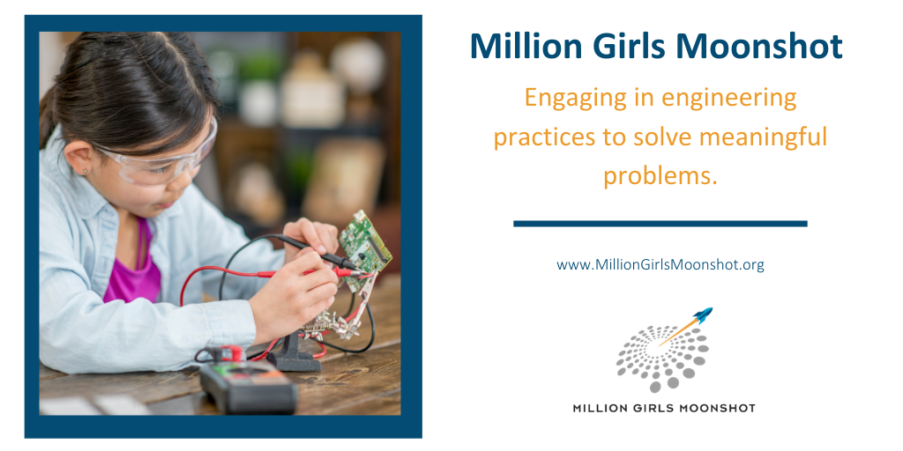

Graphics for Facebook

