Million Girls Moonshot - Media Assets
For October 2020
For the 50 State Afterschool Networks: The social media assets are designed to be used in conjunction with the content package here for dissemination between October 1-31, 2020. Contact Terri Ferinde for questions and if you need help customizing.

ASSETS for October 2020
- MIllion Girls Moonshot
- Engineering Mindset

Previous Media Asset Packages
- May Media Asset Package
- June Media Asset Package
- August Media Asset Package
- September Asset Package

Overview

The Million Girls Moonshot website is live. Feel free to share with your partners.
www.MillionGirlsMoonshot.org

Twitter: @girlsmoonshot, @STEMNext
Hashtags:
● #MillionGirlsMoonshot
● #afterschoolSTEM
● #afterschoolworks
● #thisisafterschool
● #girlsinSTEM
● #womeninSTEM
Recommended days and times to post on Facebook for education-related topics:
- Best times: Wednesday at 9 a.m. and Saturday at 5 p.m.
- Best day: Wednesday
- It is not recommended to post on Sunday

Twitter Graphics
Editable Twitter Cava Link to Graphics Can Be Found Here
Facebook Graphics
Editable Facebook Cava Link to Graphics Can Be Found Here
*When customizing canva graphics, please remember to follow our brand guidelines that can be found here

Social Posts for Twitter

Take a look! This article provides guidance on how to actively #engage students in managing #uncertainties while designing for #possibilities in their engineering process. http://stemteachingtools.org/brief/64.
Check out this blog post from @EiE_org that talks about how teaching #math and #engineering together can have a bigger impact on student learning! https://bit.ly/3kVtLQw.
Creative learning environments are so important! This blog by @DefinedLearning gives an overview of the many ways you can create a #learning environment that fosters #creativity. Visit, https://bit.ly/3i9PylH to learn more.
This blog by @EiE_org explains how the ability to generate multiple solutions to a #problem is a #skill that can help students succeed in EVERY academic field, not just science and engineering! https://bit.ly/2S7E6ME
“Afterschool staff members need access to professional development opportunities that are easily available to them.” Check out this short article by Daniele Bradshaw that describes guidelines for effective professional development for #afterschool staff! https://bit.ly/2S7E3jW
“Professional development is widely recognized as foundational to implementing high-quality programming that supports and enriches youth” Check out this article by Brasili and Allen on strategies for engineering online professional development for staff! https://bit.ly/36aeY0d
Check it out! This activity by @TpT_Official is designed to help #students understand how criteria and constraints limit potential #solutions to problems. Head over to https://bit.ly/343dpyk to access this activity.
Check this out! This worksheet from @Tpt_Official requires students to identify #criteria and constraints embedded in #rules for entering a gingerbread house contest. https://bit.ly/3l05RDz
The engineering design process goes a long way! This video highlights what real @NASA #engineers need to consider when designing spacecrafts & the kinds of trade offs they often have to make. https://bit.ly/2G69Qzv
In this engineering activity, youth review & build their knowledge of #electricity as they plan & design a dance pad that has lights and buzzer! https://to.pbs.org/33686iq @PBSKIDS
How high can a super ball bounce? In this #engineering activity, youth explore how engineers might use elasticity of #material to help them design products. https://bit.ly/2GgqhZS @TeachNgineering
We know just how important representation is! Check out this NSTA outstanding science trade book from 2019 that tells the story of how Raye Montegue, a girl with a mind for #math, fought sexism and #racial inequality to become a Navy #engineer. https://bit.ly/3jgU6rW
Building those #cognitive skills! This activity promotes creative #brainstorming by challenging students to come up with as many uses as they can for common household objects! https://bit.ly/339Tm1V
This simple PPT slide from @KQED outlines the guidelines for #brainstorming. Visit, https://bit.ly/2G5qAa4 to see all the guidelines!
Calling all #parents & #teachers. This online resource from @PBSKIDS is for parents and teachers who work with students on engineering projects. It provides #tips & prompts that you can use with students to help structure productive #brainstorming sessions! https://to.pbs.org/33auaIB
Check out this framework from @NCWIT that emphasizes “well-structured collaborative learning” & the importance of peer led instruction. https://bit.ly/36fmwyG
If you are looking for some #fun, family friendly, and educational #STEM activities, @SciGirls is here for you! Have fun designing a parachute or with a light bulb challenge at home. Visit, https://bit.ly/2S5GJi7 to learn more!

Social Posts for Facebook
Take a look! This article provides guidance on how to actively engage students in managing uncertainties while designing for possibilities in their engineering process. http://stemteachingtools.org/brief/64.
Check out this blog post from @eiemos that talks about how teaching math and engineering together can have a bigger impact on student learning! https://bit.ly/3kVtLQw.
Creative learning environments are so important! This blog by Defined Learning gives an overview of the many ways you can create a learning environment that fosters creativity. Visit, https://bit.ly/3i9PylH to learn more.
This blog by @eiemos explains how the ability to generate multiple solutions to a problem is a skill that can help students succeed in EVERY academic field, not just science and engineering! https://bit.ly/2S7E6ME
“Afterschool staff members need access to professional development opportunities that are easily available to them.” Check out this short article by Daniele Bradshaw that describes guidelines for effective professional development for afterschool staff! https://bit.ly/2S7E3jW
“Professional development is widely recognized as foundational to implementing high-quality programming that supports and enriches youth” Check out this article by Brasili and Allen on strategies for engineering online professional development for staff! https://bit.ly/36aeY0d
Check it out! This activity by @TeachersPayTeachers is designed to help students understand how criteria and constraints limit potential solutions to problems. Head over to https://bit.ly/343dpyk to access this activity.
Check this out! This worksheet from @TeachersPayTeachers requires students to identify #criteria and constraints embedded in #rules for entering a gingerbread house contest. https://bit.ly/3l05RDz
The engineering design process goes a long way! This video highlights what real @NASA engineers need to consider when designing spacecraft & the kinds of trade offs they often have to make. https://bit.ly/2G69Qzv
In this engineering activity from @PBSKIDS, youth review & build their knowledge of electricity as they plan & design a dance pad that has lights and buzzer! https://to.pbs.org/33686iq
How high can a super ball bounce? In this engineering activity from @TeachEngineeringDigitalLibrary, youth explore how engineers might use elasticity of material to help them design products. https://bit.ly/2GgqhZS
We know just how important representation is! Check out this NSTA outstanding science trade book from 2019 that tells the story of how Raye Montegue, a girl with a mind for math, fought sexism and racial inequality to become a Navy engineer. https://bit.ly/3jgU6rW
Building those cognitive skills! This activity promotes creative brainstorming by challenging students to come up with as many uses as they can for common household objects! https://bit.ly/339Tm1V
This simple PPT slide from @KQED outlines the guidelines for brainstorming. Visit, https://bit.ly/2G5qAa4 to see all the guidelines!
Calling all parents & teachers. This online resource from @PBSKIDS is for parents and teachers who work with students on engineering projects. It provides tips & prompts that you can use with students to help structure productive brainstorming sessions! https://to.pbs.org/33auaIB
Check out this framework from @NCWIT that emphasizes “well-structured collaborative learning” & the importance of peer led instruction. https://bit.ly/36fmwyG
If you are looking for some fun, family friendly, and educational STEM activities, @SciGirlstv is here for you! Have fun designing a parachute or with a light bulb challenge at home. Visit, https://bit.ly/2S5GJi7 to learn more!

Graphics for Twitter

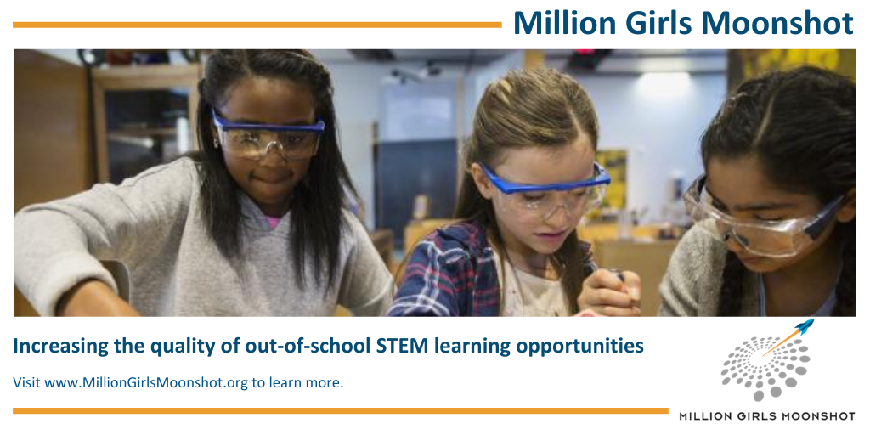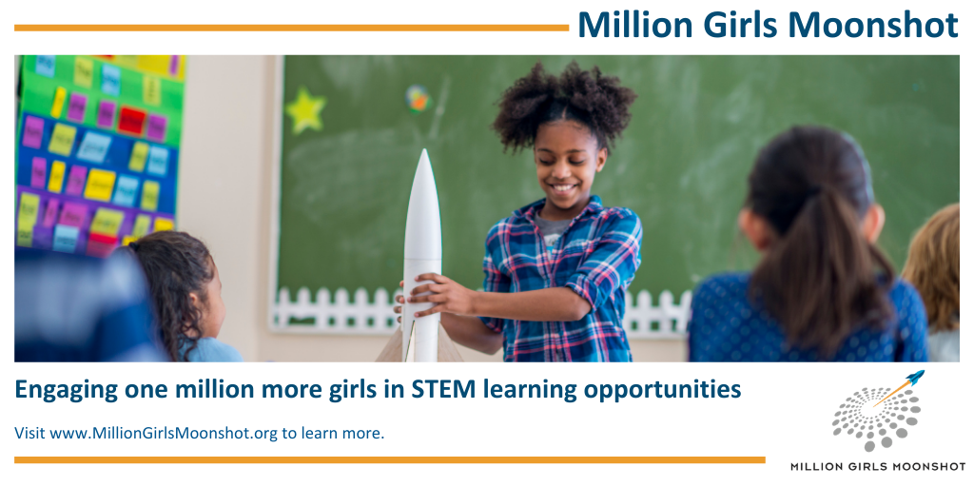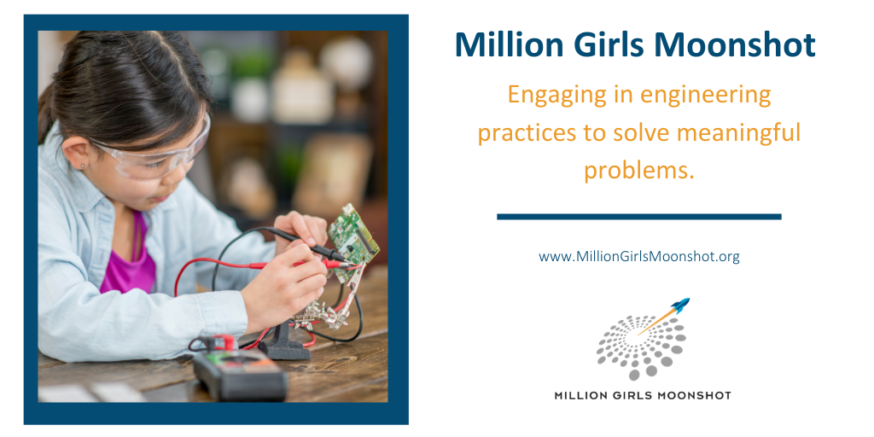

Graphics for Facebook

