Million Girls Moonshot - Media Assets
For September 2021
For the 50 State Afterschool Networks: The social media assets are designed to be used in conjunction with the content package here for dissemination between September 1-30, 2021. Contact Terri Ferinde for questions and if you need help customizing.

Content assets for September 2021

Previous Media Asset Packages

Overview

The Million Girls Moonshot website is live. Feel free to share with your partners.
www.MillionGirlsMoonshot.org

Twitter: @girlsmoonshot, @STEMNext
Hashtags:
● #MillionGirlsMoonshot
● #afterschoolSTEM
● #afterschoolworks
● #thisisafterschool
● #girlsinSTEM
● #womeninSTEM
Recommended days and times to post on Facebook for education-related topics:
- Best times: Wednesday at 9 a.m. and Saturday at 5 p.m.
- Best day: Wednesday
- It is not recommended to post on Sunday

Twitter Graphics
Editable Twitter Canva Templates Can Be Found Here
Facebook Graphics
Editable Facebook Canva Templates Can Be Found Here
*When customizing canva graphics, please remember to follow our brand guidelines that can be found here

Social Posts for Twitter

Booster Packs
- Calling all curious teens! Join @TeenScienceCafe for FREE conversations with #STEM experts. Check it out → https://bit.ly/3zoA8D5

Featured Webinars
- Check out all the free design challenges offered on the @technovation Curiosity Machine website. Register for this webinar to learn more: https://bit.ly/3zoBg9N
- Intel Future Skills Educator Academy gives you the opportunity to help build the next generation of #STEM leaders. Don’t miss it! https://bit.ly/3yCwAgx @intel
- #AI is connected to real life -- and you can learn how! Get the latest on artificial intelligence and how it works to solve problems: https://bit.ly/3y0o7DB @technovation
- Let’s engage with tech to solve issues affecting us all. Don’t miss hearing about the @technovation global program. Dive in! https://bit.ly/3zyr3I1
- This one’s for the “M” in #STEM -- join an @IfThenSheCan ambassador to talk math in #afterschool: https://bit.ly/3zyr3I1 @ngcproject #afterschoolSTEM

Featured Webinars (For Programs)

- Don’t miss this! Webinar: Possible Futures (PF) Engineering & Design from @jfftweets curriculum on Oct. 14 at 3pm ET! Register here → https://bit.ly/3AtUFXp
- [WEBINAR] Part II of @jfftweets webinar on the FREE Possible Futures (PF) Engineering & Design curriculum is Nov. 3 at 3pm ET: https://bit.ly/2XfwDkG

Featured Webinars (For Partners & Programs)
- Support #STEM in #afterschool -- dive in w/ @IfThenSheCan & their new afterschool portal and discover resources & activities: https://bit.ly/3rvyFrJ @ngcproject #afterschoolSTEM
- Get ready for Camp @goldieblox campers! Watch with @ngcproject to find resources to inspire the next generation of #girlsinSTEM: https://bit.ly/3eK4vMr
- It’s your chance to make an impact as a role model. Access this training from @techbridgegirls to be the best you can be! https://bit.ly/3zHLfaz #girlsinSTEM #womeninSTEM

Transformative Practices
- Extra, extra! Read all about THIS → Creating Pathways for Equity in STEM Through Family Engagement: https://bit.ly/3AtVXSf @NSTA
- From @NIOSTnews: Explore how to engage girls from rural communities in #STEM → https://bit.ly/3xw1OVe
- Check out this printable graphic on the 10 critical engineering practices: https://bit.ly/3xx2iu9 #STEM
- So what is a #STEM mindset? Read on for why everyone should have one → https://bit.ly/2VLbVsv @NSTA
- From @GG_Learning: this video helps your grade schooler learn more about engineering: https://bit.ly/3yEJ9Yy
Hispanic Heritage Month
- This #HispanicHeritageMonth, “think about your passion.” Check out this video to hear more from @IfThenSheCan ambassador Bea Mendez Gandica → https://bit.ly/3sbyceF #womeninSTEM
- Dig into this video on Paleontologist & @IfThenSheCan ambassador @paleontologica_ https://bit.ly/3CK6lqQ #womeninSTEM #HispanicHeritageMonth
- 📷Happy #HispanicHeritageMonth @paleontologica_! You’re dino-mite https://bit.ly/37A4iYj #womeninSTEM
- This #MicrobeMonday learn more about the work of @IfThenSheCan ambassador @AnaMaPorras → https://bit.ly/3iCY2Fg #HispanicHeritageMonth
- This #HispanicHeritageMonth we are celebrating our #womeninStem 🔬-- say cheese, @AnaMaPorras! https://bit.ly/37EzhlK
- Engineers solve problems. Watch this video for more on #womeninSTEM like @IfThenSheCan ambassador @WatchMeSTEM: https://bit.ly/37Ca4Zl
Hispanic Heritage Month (For Programs)
- Happy #HispanicHeritageMonth @paleontologica_! You’re dino-mite 🦖 https://bit.ly/37A4iYj #womeninSTEM
- We dig learning more about paleontology from @paleontologica_ and know you will too! Check this out: https://bit.ly/3CK6lqQ #womeninSTEM #HispanicHeritageMonth
- This #HispanicHeritageMonth hear more about the #STEM journey of @IfThenSheCan ambassador @paleontologica_ → https://bit.ly/3sbZktZ #womeninSTEM
- Check out this scrumptious activity featuring @IfThenSheCan ambassador @paleontologica_: https://bit.ly/2VQwljF @goldieblox #womeninSTEM #HispanicHeritageMonth
- THIS is what a scientist looks like! @paleontologica_ #womeninSTEM #HispanicHeritageMonth https://bit.ly/3ADaQSh
- Celebrate #HispanicHeritageMonth with us and @IfThenSheCan ambassador @AnaMaPorras! https://bit.ly/37EzhlK
- Studying microbes in the lab & a master crocheter? Hear more from @IfThenSheCan ambassador @AnaMaPorras! Check this out: https://bit.ly/3iCY2Fg #HispanicHeritageMonth #womeninSTEM
- How many microbes live in our bodies? Find out the answer from @AnaMaPorras → https://bit.ly/3lZle2O @GoldieBlox #HispanicHeritageMonth #womeninSTEM
- Looking for a fun #STEM activity this #HispanicHeritageMonth? Learn more about space communicator Dana Bolles → https://bit.ly/37EQT18
- So, are there really aliens out there?! Explore space & more with Dana Bolles 🌎🪐💫 https://bit.ly/3lXMyOX #HispanicHeritageMonth #womeninSTEM
- Did you know chemists can work with makeup?! Learn more from @IfThenSheCan ambassador @RoselinRosario3 → https://bit.ly/2VQb4GX #HispanicHeritageMonth #girlsinSTEM #womeninSTEM
- Crochet a friendship bracelet -- and learn more about bacteria! Thanks, @AnaMaPorras https://bit.ly/3jMYosh @GoldieBlox #HispanicHeritageMonth #girlsinSTEM
- We love this #DIY: dig for dinos with @paleontologica_ → https://bit.ly/3scN3FL @GoldieBlox #STEM #HispanicHeritageMonth

Families
- Don’t miss out on these #STEM activities from @BosChildMuseum! https://bit.ly/3lVflDx

STEM Transitions, Handoffs, and Coordination
- Check out this case study of a design-led learning innovation to deepen interest-driven learning pathways for youth: https://bit.ly/3ACcXFT

Activities for Programs
- For out of this world activities for kids, check out @NASAspaceplace → https://spaceplace.nasa.gov/
- Take a deep dive with these coloring pages, experiments, videos and more from @NOAA: https://bit.ly/3AQwxi3
- Don’t miss these 50+ fun engineering activities for kids of all ages using simple household items → https://bit.ly/3CIrWA4
- Fly to the highest heights with your growing engineer -- try this Take Flight activity & explore how flight is possible: https://bit.ly/3zBwEgx @TryEngineering

- Chill out with your student #engineer. Design, build, and test a cooler with @TeachNgineering → https://bit.ly/3kYBBfd

Additional Professional Development
- Stereotypes in #STEM are too common - for girls and especially girls of color. Join @ngcproject to hear more on how you can engage in these challenging conversations & help girls see themselves in #STEM → https://bit.ly/3iS1ZES #girlsinSTEM
- Learn how to have engaging conversations with youth about the stereotypes and biases in #STEM. Don’t miss this webinar from @ngcproject: https://ngcproject.org/addressing-stem-stereotypes-and-biases-facilitating-challenging-conversations-with-youth

Mizzen by Mott Moonshot Connection
- On the @MizzenbyMott app: check out a playlist to get your 3rd-5th grader outside and learning about how to help the environment 🌎https://bit.ly/3fUXid6
- Make It Move Invention Camp: engineering activities for youth in 6th-8th grade. On the Mizzen app! @MizzenbyMott https://bit.ly/3fUXid6
- Design, build, and test an extension arm! Check it out today -- on the @MizzenbyMott app! https://bit.ly/3fUXid6

Social Posts for Facebook

Booster Packs
- Calling all curious teens! Join Teen Science Cafe for FREE conversations with #STEM experts. Check it out → https://bit.ly/3zoA8`D5

Featured Webinars
- Check out all the free design challenges offered on the @technovationglobal Curiosity Machine website. Register for the webinar to learn more: https://bit.ly/3zoBg9N
- @Intel Future Skills Educator Academy gives you the opportunity to help build the next generation of #STEM leaders. Don’t miss it! https://bit.ly/3yCwAgx
- #AI is connected to real life -- and you can learn how! Get the latest on artificial intelligence and how it works to solve problems: https://bit.ly/3y0o7DB @technovationglobal
- Let’s engage with tech to solve issues affecting us all. Don’t miss hearing about the @technovationglobal global program. Dive in! https://bit.ly/3zyr3I1
- This one’s for the “M” in #STEM -- join an @IfThenInitiative ambassador to talk math in #afterschool: https://bit.ly/3zyr3I1 @ngcproject #afterschoolSTEM

Featured Webinars (For Programs)

- Don’t miss this! Webinar: Possible Futures (PF) Engineering & Design from @jobsforthefuture curriculum on Oct. 14 at 3pm ET! Register here → https://bit.ly/3AtUFXp
- [WEBINAR] Part II of @jobsforthefuture webinar on the FREE Possible Futures (PF) Engineering & Design curriculum is Nov. 3 at 3pm ET: https://bit.ly/2XfwDkG

Featured Webinars (For Partners & Programs)
- Support #STEM in #afterschool -- dive in w/ @IfThenInitiative & their new afterschool portal and discover resources & activities: https://bit.ly/3rvyFrJ @ngcproject #afterschoolSTEM
- Get ready for Camp @GoldieBlox campers! Watch with @ngcproject to find resources to inspire the next generation of #girlsinSTEM: https://bit.ly/3eK4vMr
- It’s your chance to make an impact as a role model. Access this training from @techbridgegirls to be the best you can be! https://bit.ly/3zHLfaz #girlsinSTEM #womeninSTEM

Transformative Practices
- Extra, extra! Read all about THIS → Creating Pathways for Equity in STEM Through Family Engagement: https://bit.ly/3AtVXSf @NSTA.FB
- From @NationalInstituteonOutofSchoolTime: Explore how to engage girls from rural communities in #STEM → https://bit.ly/3xw1OVe
- Check out this printable graphic on the 10 critical engineering practices: https://bit.ly/3xx2iu9 #STEM
- So what is a #STEM mindset? Read on for why everyone should have one → https://bit.ly/2VLbVsv @NSTA.FB
- From @GGenius: this video helps your grade schooler learn more about engineering: https://bit.ly/3yEJ9Yy
Hispanic Heritage Month
- This #HispanicHeritageMonth, “think about your passion.” Check out this video to hear more from @IfThenInitiative ambassador Bea Mendez Gandica → https://bit.ly/3sbyceF #womeninSTEM
- Dig into this video on Paleontologist & @IfThenInitiative ambassador Myria Perez Long https://bit.ly/3CK6lqQ #womeninSTEM #HispanicHeritageMonth
- 📷Happy #HispanicHeritageMonth Myria Perez Long! You’re dino-mite https://bit.ly/37A4iYj #womeninSTEM
- This #MicrobeMonday learn more about the work of @IfThenInitiative ambassador Ana Maria Porras → https://bit.ly/3iCY2Fg #HispanicHeritageMonth
- This #HispanicHeritageMonth we are celebrating our #womeninStem 🔬-- say cheese, Ana Maria Porras! https://bit.ly/37EzhlK
- Engineers solve problems. Watch this video for more on #womeninSTEM like @IfThenInitiative ambassador Paula Garcia Todd: https://bit.ly/37Ca4Zl
Hispanic Heritage Month (For Programs)
- Happy #HispanicHeritageMonth Myria Perez Long! You’re dino-mite 🦖 https://bit.ly/37A4iYj #womeninSTEM
- We dig learning more about paleontology from Myria Perez Long-- and know you will too! Check this out: https://bit.ly/3CK6lqQ #womeninSTEM #HispanicHeritageMonth
- This #HispanicHeritageMonth hear more about the #STEM journey of @IfThenInitiative ambassador Myria Perez Long → https://bit.ly/3sbZktZ #womeninSTEM
- Check out this scrumptious activity featuring @IfThenInitiative ambassador Myria Perez Long: https://bit.ly/2VQwljF @goldieblox #womeninSTEM #HispanicHeritageMonth
- THIS is what a scientist looks like! @IfThenInitiative #womeninSTEM #HispanicHeritageMonth https://bit.ly/3ADaQSh
- Celebrate #HispanicHeritageMonth with us and @IfThenInitiative ambassador Ana Maria Porras! https://bit.ly/37EzhlK
- Studying microbes in the lab & a master crocheter? Hear more from @IfThenInitiative ambassador Ana Maria Porras! Check this out: https://bit.ly/3iCY2Fg #HispanicHeritageMonth #womeninSTEM
- How many microbes live in our bodies? Find out the answer from Ana Maria Porras → https://bit.ly/3lZle2O @GoldieBlox #HispanicHeritageMonth #womeninSTEM
- Looking for a fun #STEM activity this #HispanicHeritageMonth? Learn more about space communicator Dana Bolles → https://bit.ly/37EQT18
- So, are there really aliens out there?! Explore space & more with Dana Bolles 🌎🪐💫 https://bit.ly/3lXMyOX #HispanicHeritageMonth #womeninSTEM
- Did you know chemists can work with makeup?! Learn more from @IfThenInitiative ambassador @linromel → https://bit.ly/2VQb4GX #HispanicHeritageMonth #girlsinSTEM #womeninSTEM
- Crochet a friendship bracelet -- and learn more about bacteria! Thanks, Ana Maria Porras https://bit.ly/3jMYosh @GoldieBlox #HispanicHeritageMonth #girlsinSTEM
- We love this #DIY: dig for dinos with Myria Perez Long → https://bit.ly/3scN3FL @GoldieBlox #STEM #HispanicHeritageMonth

Families
- Don’t miss out on these #STEM activities from @BostonChildrensMuseum! https://bit.ly/3lVflDx

STEM Transitions, Handoffs, and Coordination
- Check out this case study of a design-led learning innovation to deepen interest-driven learning pathways for youth: https://bit.ly/3ACcXFT

Activities for Programs
- For out of this world activities for kids, check out @nasaspaceplace → https://spaceplace.nasa.gov/
- Take a deep dive with these coloring pages, experiments, videos and more from @NOAA: https://bit.ly/3AQwxi3
- Don’t miss these 50+ fun engineering activities for kids of all ages using simple household items → https://bit.ly/3CIrWA4
- Fly to the highest heights with your growing engineer -- try this Take Flight activity & explore how flight is possible: https://bit.ly/3zBwEgx @TryEngineering.org

- Chill out with your student #engineer. Design, build, and test a cooler with @TeachEngineeringDigitalLibrary → https://bit.ly/3kYBBfd

Additional Professional Development
- Stereotypes in #STEM are too common - for girls and especially girls of color. Join @ngcproject to hear more on how you can engage in these challenging conversations & help girls see themselves in #STEM → https://bit.ly/3iS1ZES #girlsinSTEM
- Learn how to have engaging conversations with youth about the stereotypes and biases in #STEM. Don’t miss this webinar from @ngcproject: https://ngcproject.org/addressing-stem-stereotypes-and-biases-facilitating-challenging-conversations-with-youth

Mizzen by Mott Moonshot Connection
- On the @MizzenbyMott app: check out a playlist to get your 3rd-5th grader outside and learning about how to help the environment 🌎https://bit.ly/3fUXid6
- Make It Move Invention Camp: engineering activities for youth in 6th-8th grade. On the Mizzen app! @MizzenbyMott https://bit.ly/3fUXid6
- Design, build, and test an extension arm! Check it out today -- on the @MizzenbyMott app! https://bit.ly/3fUXid6

Graphics for Twitter
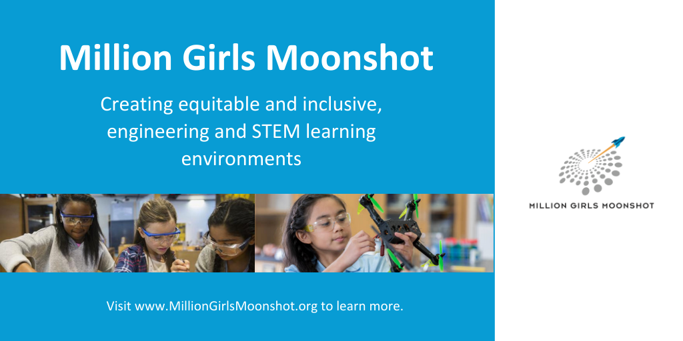

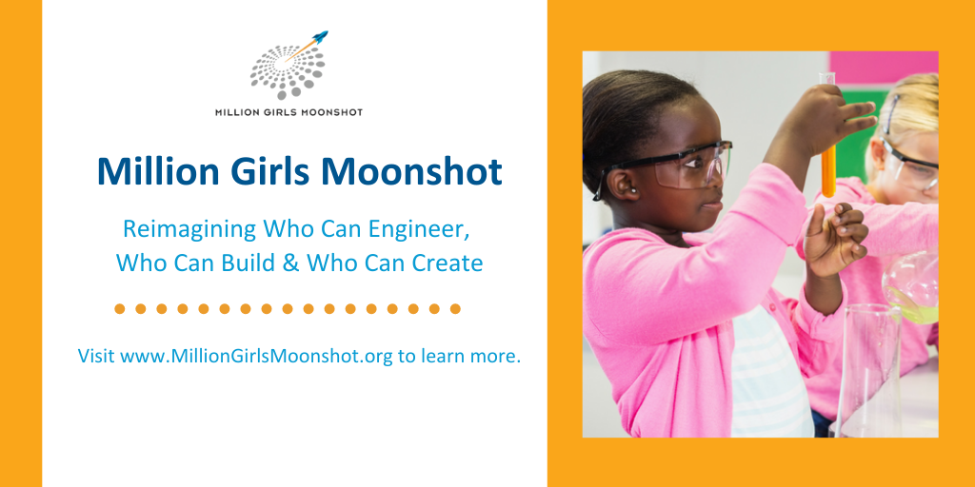

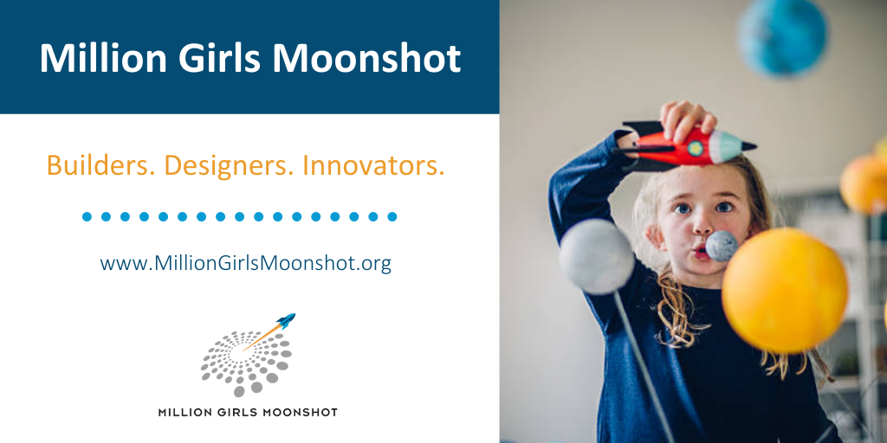

Graphics for Facebook
