TAN Grant
Peabody High School, Trenton, Tn
Peabody Serves through Sewing

Description:

Students indicated a desire to learn to sew. At the same time, Peabody Serves pairs with Trenton Health and Rehabilitation for service projects. The director indicated a need for decorative pillowcases for the residents, both for their functionality and for brightness and cheer. We paired these two things together and decided to teach kids sewing through sewing the needed pillowcases. This grant enabled us to purchase a portion of the needed supplies for the project.

Activities included a great deal of planning. How many pillowcases are we going to make? How much fabric do we need to make these? What other supplies do we need? How are we going to organize the students as they learn to sew? When will we meet and work? What sort of fabric should we use? When are the completed pillowcases needed?

After supplies were readied and plans were organized, the students (thirteen female students) met to work for several two-hour sessions. The sessions were divided into work stations (measuring and cutting, serging, ironing, sewing, and finishing). All students rotated through the stations, allowing each student to learn all steps of the construction process. An additional issue that arose was that one of the purchased sewing machines would not operate properly and had to be returned and exchanged for another one. In addition, we had more participants than we anticipated and had to bring our personal machines from home to accommodate the large number.

At the completion of the project, the director of Trenton Health and Rehabilitation Center came to view and receive the completed pillowcases - success! Not only will the residents receive homemade gifts completed with love, but thirteen girls learned valuable skills that can be used throughout their lives.

Outcome:

After many hours of planning, preparation, and creating, Peabody Serves was able to present Trenton Health and Rehabilitation Center fifty completed pillowcases of varying patterns for their residents to use and enjoy.

In addition, thirteen students learned useful sewing skills. All have indicated an interest in continuing use of these skills. Plans are underway now for a “sewing camp” to be held this summer.

Participants:

Sixteen students (freshmen through senior) participated in the project. Their ages ranged from 14-17. We had one male student participate in the project.

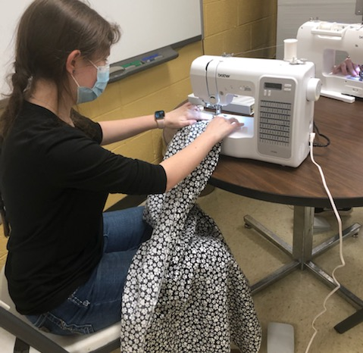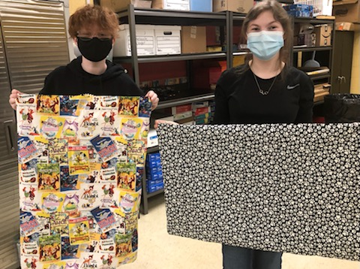

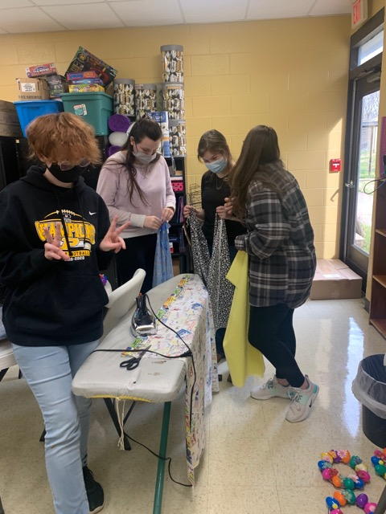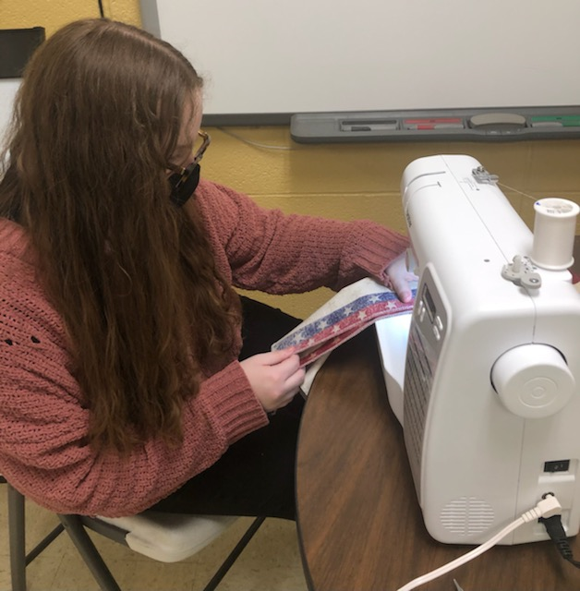
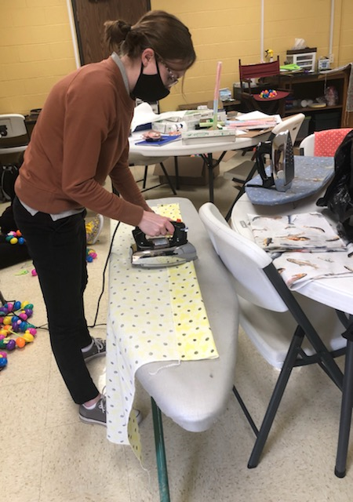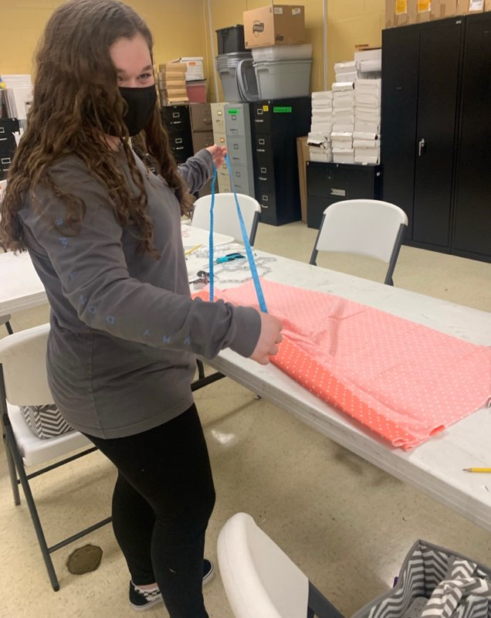
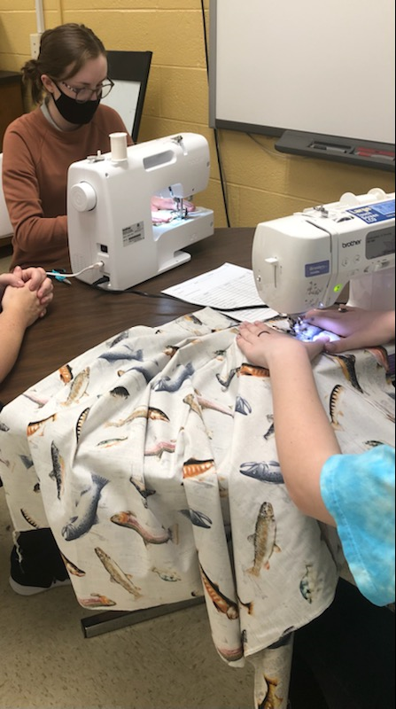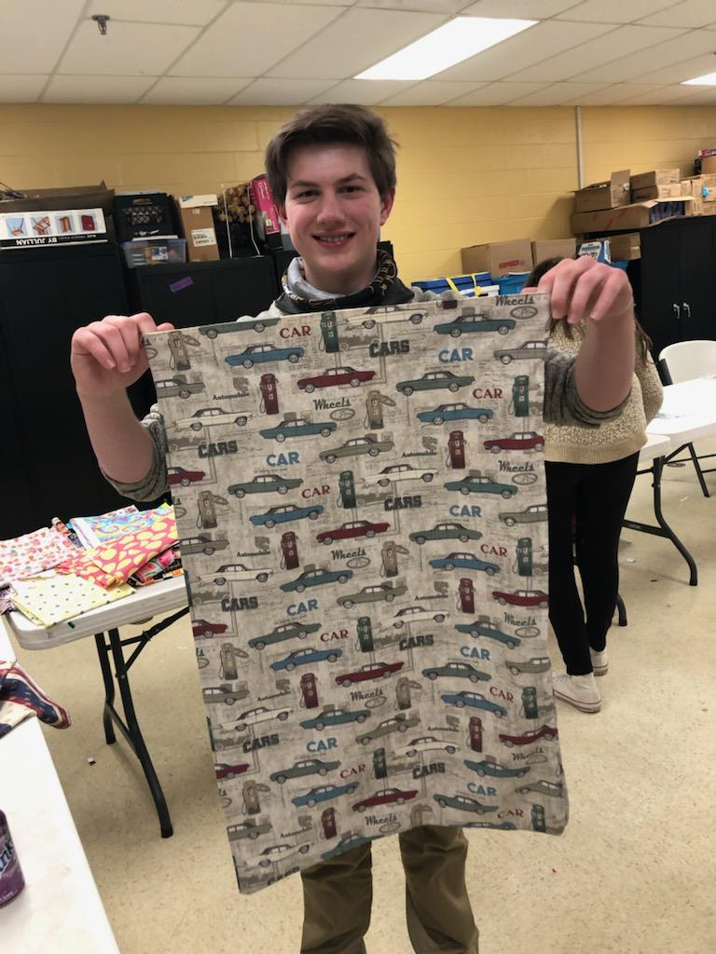

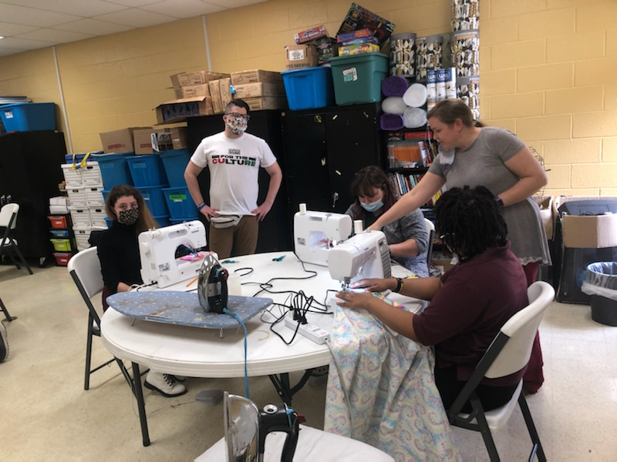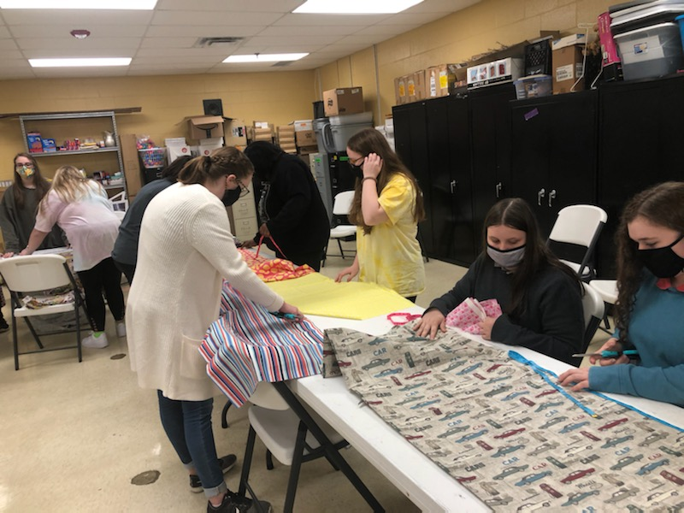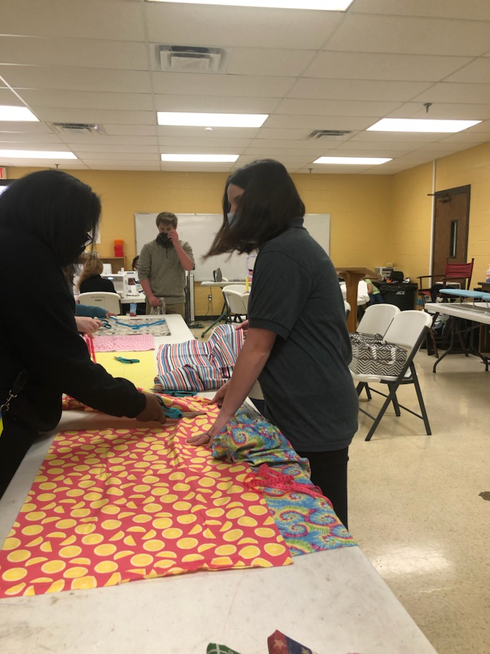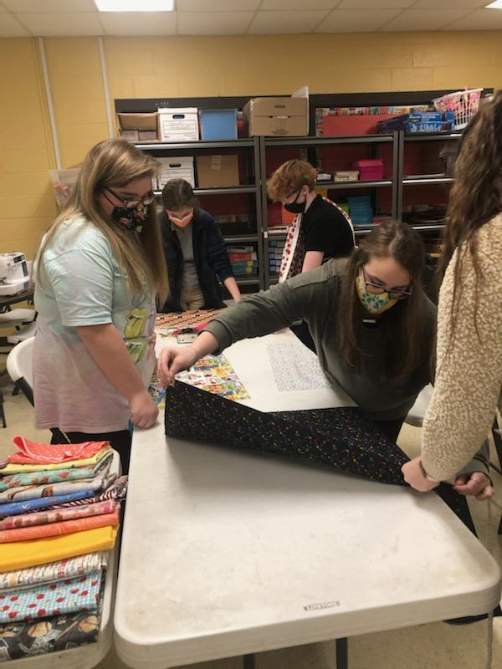

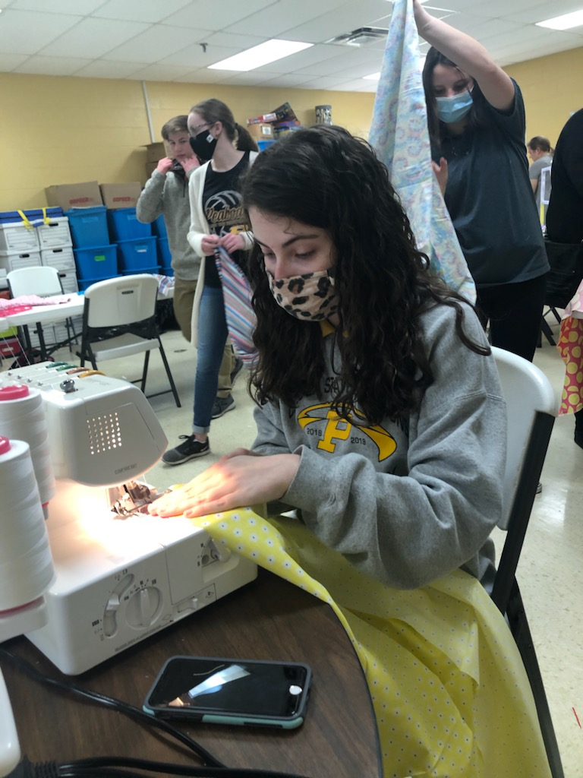
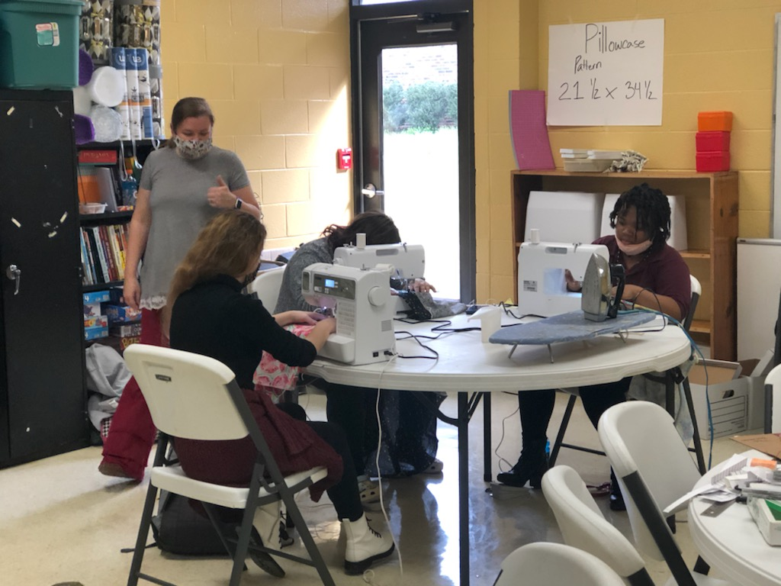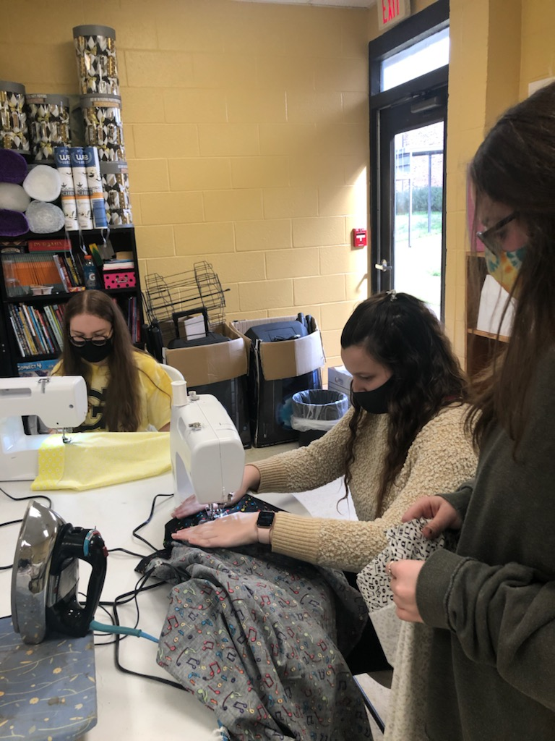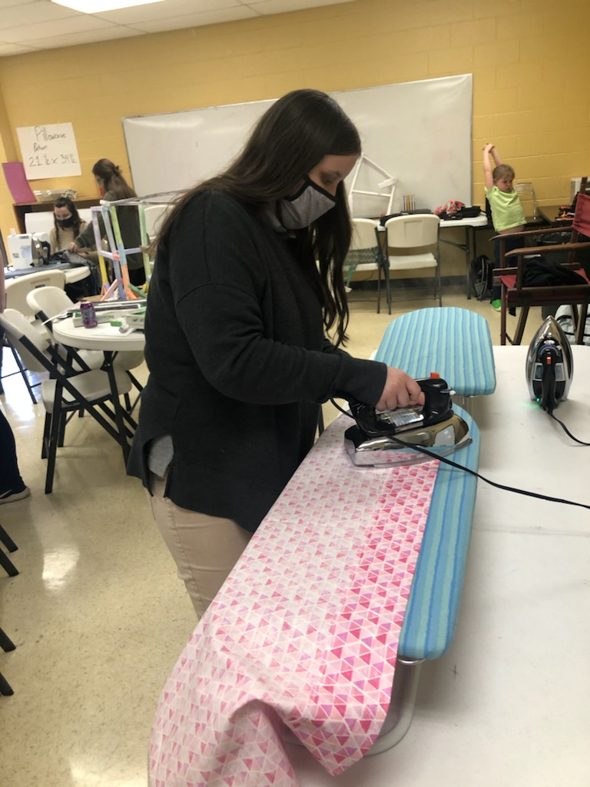

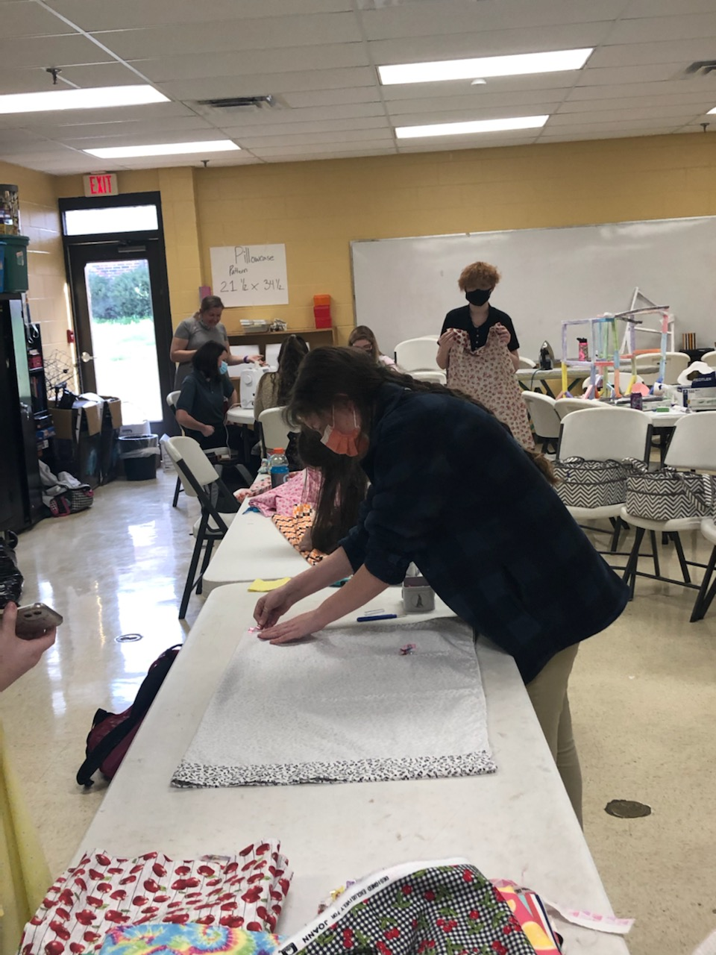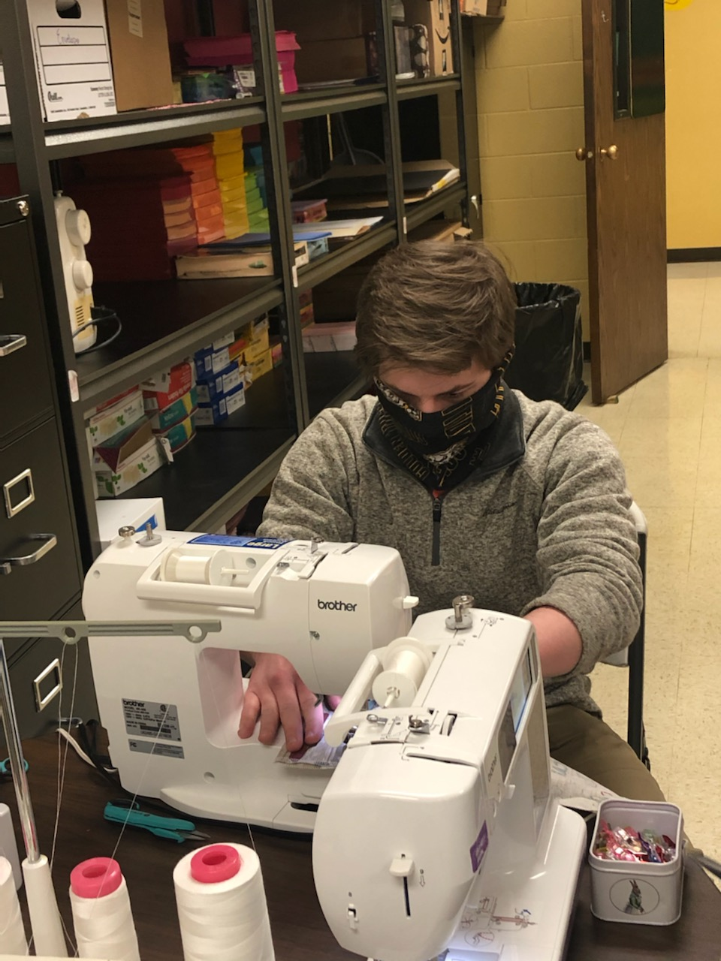
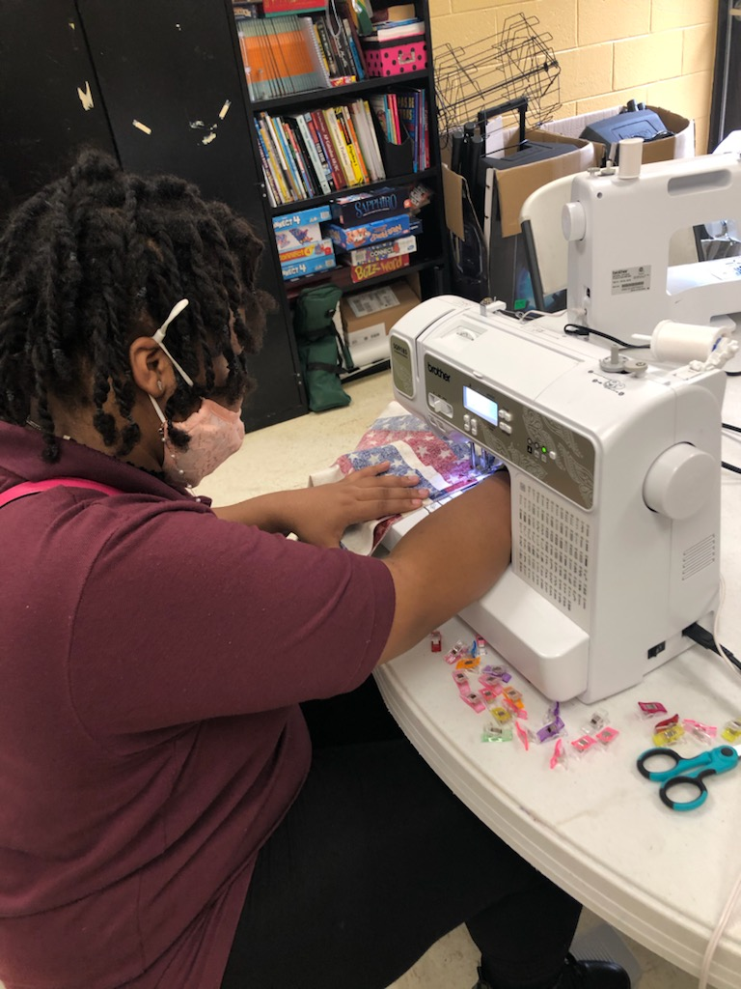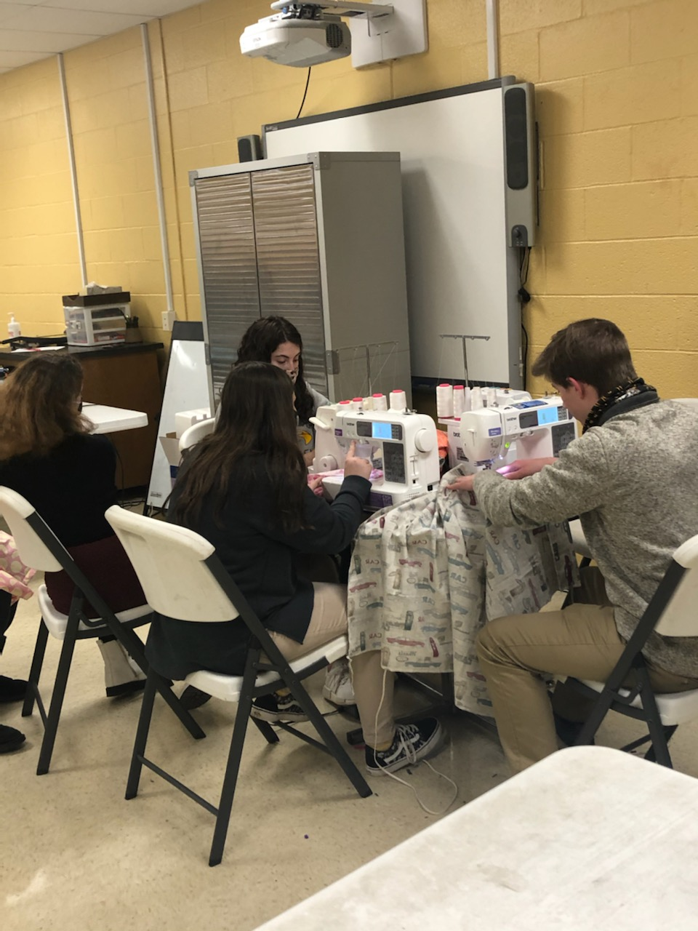

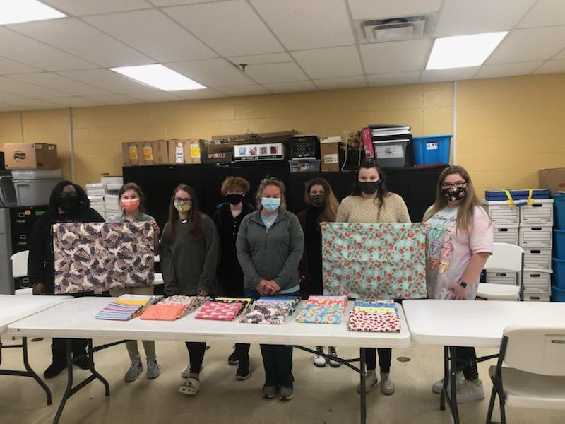
Completed Project with Katie Burke of Trenton Health and Rehabilitation Center

