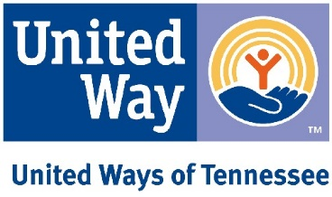

TANF Fair Share
HB 2509 (Hawk)/SB 2797 (Akari)

- MAINTAIN A RESERVE: We agree that Tennessee needs a healthy reserve in the event of a recession, but it should be more in line with other states.

  - While the TANF working group endorsed the Department of Human Services (DHS) recommendation of maintaining a $342 million reserve, we recommend allowing the Comptroller to make a recommendation.

  - The more progressive Center for Budget and Policy Priorities recommends a reserve of $191 million and the more conservative Beacon Center has recommended $210 million. Both numbers are considerably less than the department’s recommendation.

- ALLOCATE ‘FAIR SHARE’: Minus the above mandated reserve, DHS should allocate ongoing annual TANF funding on a “fair share” basis, to counties, based on the percentage of population in poverty.

  - TN gets $191 million each year from the federal government. The Beacon Center reported Tennessee is only spending about $70 million per year.

  - DHS would continue to administer the funds through awarding grants to qualified agencies for TANF-allowed expenses, not by distributing funds directly to county governments.

- INVEST the SUPLUS and EVALUATE the RESULTS:

  - Prioritize Evidence-Based Home Visiting (EBVH) by allocating $75 million through the Department of Health. EBVH is a 2 Generation approach.

  - Allocate $100 million to before, after, summer care with a literacy component approved by TDOE.

  - Use a third-party evaluator to measure the success of these programs so taxpayers can be assured the funds are spent judiciously.

