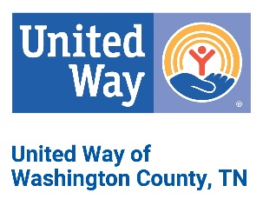
Did you know?
Proficient 3rd grade readers are more
likely to be high school graduates and
economically successful adults!

Help K-3rd grade children read
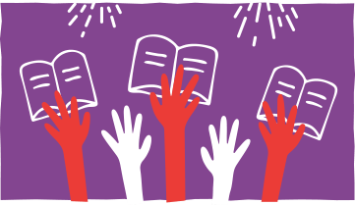
Vello is a 1-on-1 online tutoring program that makes volunteering easy. It connects passionate professionals with kids in their community for 30-minute guided reading with super simple screen sharing and audio.

Why you should volunteer
Reading is the foundation of a successful education. Vello volunteers support kids learning to read, so they can read to learn. A little of your time can go a long way in supporting students who are working hard to read at grade level so they can do well in school and life.

Vello makes it easy
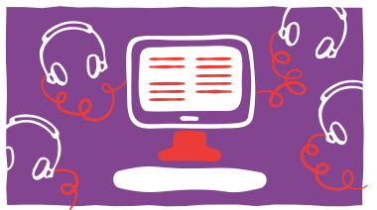
The Vello program was designed to fit seamlessly into the lives of passionate professionals. Volunteers easily connect with students in an online tutoring environment, empowering them to make a real difference from any device, anywhere.

Sign up to make a difference
Volunteers can sign up by contacting Kristan Ginnings, President & CEO, United Way of Washington County, TN by phone at 423-220-1235 or by e-mail at kginnings@uwowc.org.

