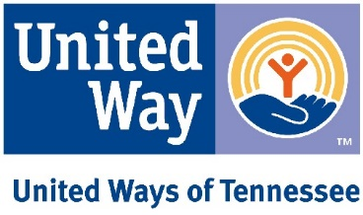

Digital Advocacy Event Training Agenda
United Ways of Tennessee – Save the Children – Tennessee Afterschool Network

Date/Time: 10 Central March 16th

Access Information: 712-775-7031, meeting id 611-496-968

AGENDA:

Welcome and background: Linda O’Neal, UWTN and TN Afterschool Network (TAN) public policy chair (10 Minutes)

Vaping legislation, OST: Mary Graham (UWTN/TAN) (10 Minutes)

TANF legislation: Mike Carpenter, Tennesseans for Quality Early Education (15 Minutes)

Social media: Kelley Nave, UWTN and TAN consultant (10 minutes)

Questions (15 minutes)

