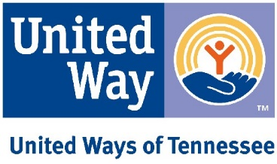

Day on the Hill Agenda
United Ways of Tennessee – Save the Children – Tennessee Afterschool Network

Cordell Hull Building, 425 5th Ave. North
Senate Hearing Room 2, 1st Floor
Tuesday, March 5th, 2019
8:45am – 10:15am

8:45am: Welcome (Linda O’Neal)

9:00am: Overview of ACES (Linda O’Neal)

9:15am: Review of work reporting requirements and Afterschool issues (Mary Graham)

9:25am: Social media engagement (Kelley Nave)

9:30am: Advocacy 101 practice (Ashley Warrington, Jacy Warrell)

9:40am: “How to Have an Effective Legislative Visit” (Representative Harold Love)

9:50am: Bringing it all together, Final Tips/Reminders (Jacy Warrell, Ashley Warrington)

10:00am: 2019 Legislative Champion Awards:
- Senator Bo Watson
- Representative David B. Hawk

